**Neural plasticity underlies transcranial direct-current stimulation (tDCS) in humans**

Chong Zhao & Geoffrey F. Woodman*

Department of Psychology, Center for Integrative and Cognitive Neuroscience, Vanderbilt Vision Research Center, Vanderbilt University, Nashville, Tennessee 37240, USA

* Correspondence to:

Geoffrey F. Woodman

PMB 407817

2301 Vanderbilt Place

Vanderbilt University, Nashville, TN 37240-7817

E-mail: [geoffrey.f.woodman@vanderbilt.edu](mailto:geoffrey.f.woodman@vanderbilt.edu)

Abstract: 70 words

Words in Introduction and Discussion sections: 730 words

Figures: 3

**Acknowledgements**

Grants were provided by the National Institutes of Health to GFW (R01-EY019882, R01-MH110378, and P30-EY08126).

**Research with animal models has suggested that direct-current stimulation of the brain has long lasting after effects due to its induction of increased synaptic plasticity. We tested this hypothesis in human subjects by delivering transcranial direct-current stimulation to the temporal pole and then showing them hundreds of pictures of objects to remember. We show that pictures were encoded with a higher fidelity following anodal stimulation, a lower fidelity following cathodal stimulation, and that there were no improvements in memory when stimulation followed the encoding of the pictures. These findings provide some of the first evidence from humans that direct-current stimulation modulates synaptic plasticity.**

Stimulating the brain with weak direct current has long been known to trigger polarity dependent changes in brain function that can last for hours 1,2. An early hypothesis was that the changes in brain function persisted for such a long period because the electrical field induced by stimulation promotes protein synthesis and synaptic plasticity 3. This hypothesis has received support from rodent work in brain slices and in vivo [refs]. However, predictions of the synaptic-plasticity hypothesis have yet to be tested in the human brain. 

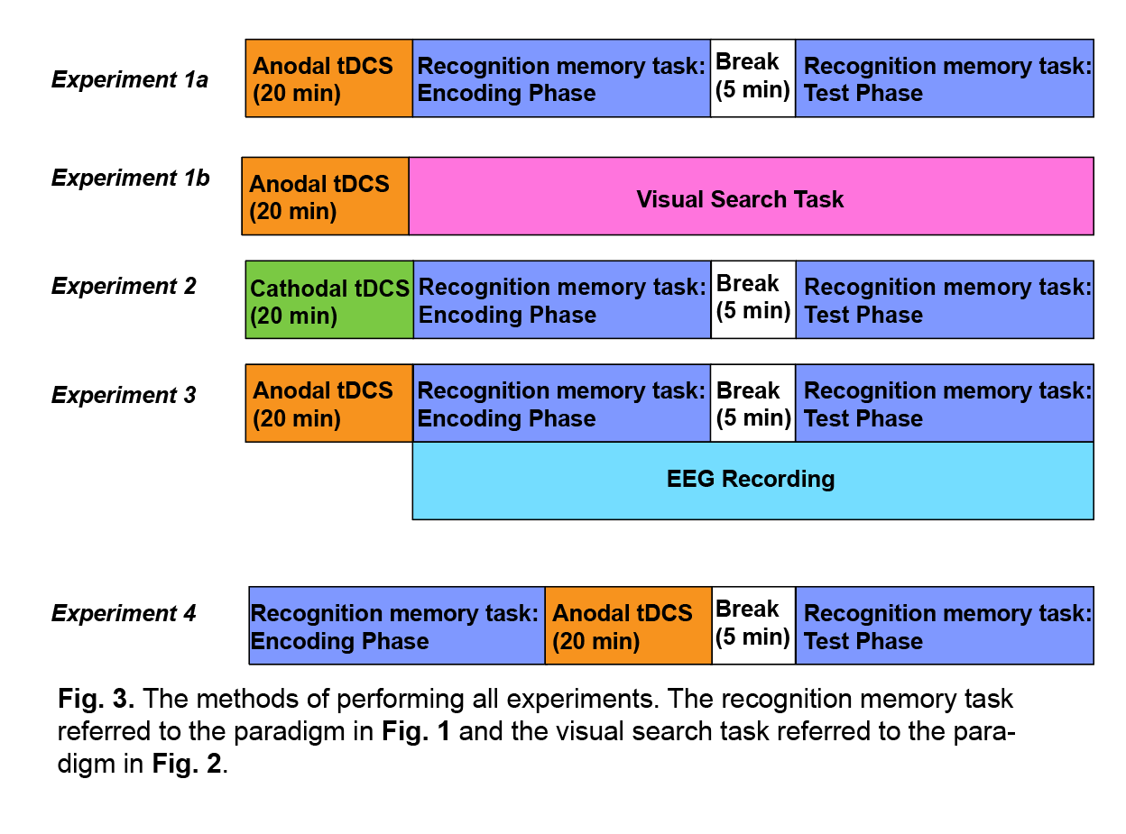 If transcranial Direct-Current Stimulation (tDCS) is changing the plasticity of the brain, then tDCS should impact the encoding of an episode into memory when connections are made to store information, but should not affect retrieval when those connections are used. In addition, if the bi-directional effects of tDCS are due to facilitation versus interference with the formation of synaptic connections, then we should see anodal stimulation improve memory encoding and cathodal stimulation impair memory encoding. Next, tDCS should change performance in memory-demanding tasks, but not other effortful tasks that tax non-memory mechanisms of the brain (e.g., visual attention). Finally, tDCS should change neurophysiological indices of memory encoding, but have little effect on retrieval-related electrical brain activity. Here we tested this set of predictions of the synaptic-plasticity hypothesis by targeting portions of the temporal lobe that represent high-level object properties. This well studied portion of the ventral visual system is an ideal locus in which to test our predictions because empirical work has shown that it is possible to see memory effects in the cortex at the temporal pole 4, particularly memory for objects we experience visually 5.

In Experiment 1, subjects performed a recognition-memory task in which they viewed 500 pictures of common objects following 20 minutes of anodal stimulation delivered to the temporal pole (see **Fig. 1**). These same subjects performed the same task on a different day (order counterbalanced) following sham stimulation that mimicked the sensations felt during active stimulation, with blinding confirmed by post-experiment debriefing questions. In Experiment 2, we reversed the direction of current flow, using cathodal stimulation compared with each subject’s sham baseline. Experiment 3 measured the effects of temporal pole tDCS on visual search performance, a task that does not demand constant memory encoding. In Experiment 4, we stimulated prior to memory retrieval to determine if tDCS could change memory retrieval operations, even when performed immediately after stimulation. Finally, in Experiment 5, we examined the effects of tDCS on neurophysiological correlates of encoding and retrieval from human memory. An overview of the methodological differences between experiments is shown in **Figure 2**.

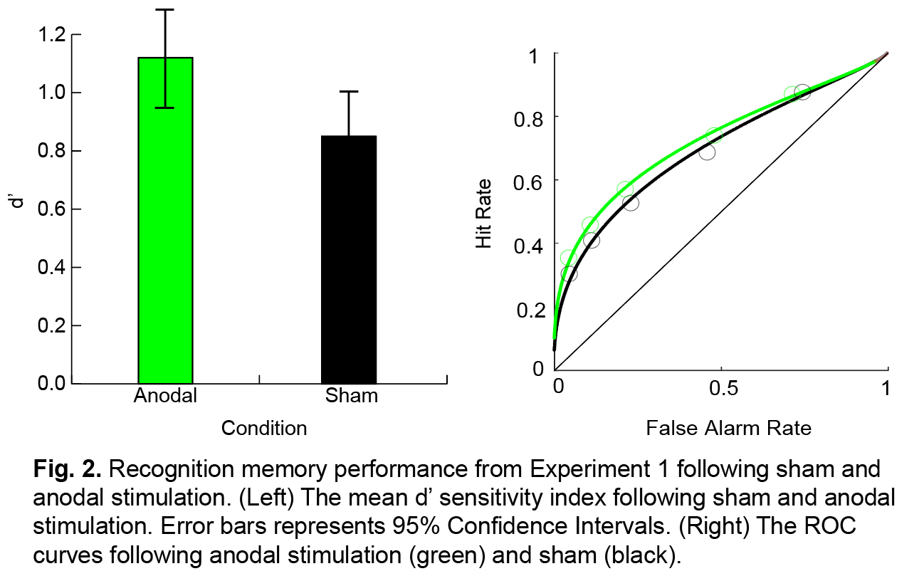**Results**

**Figure 3** shows the findings from Experiment 1 and Experiment 2. In Experiment 1, anodal stimulation delivered to the temporal temporal pole improved recognition memory, regardless of which hemisphere was stimulated. Specifically, we observed higher d’ sensitivity compared to the sham stimulation baseline (*F*(31)= 16.504, *p*<0.001). In contrast, In Experiment 2 cathodal stimulation deteriorated performance (*F*(31)= 6.162, *p*=0.019). Neither anodal stimulation in Experiment 1, nor cathodal stimulation in Experiment 2, showed a significant hemispheric preference (i.e., an interaction of stimulation condition x hemisphere, *F*(31)= 0.097, *p*=0.752, for Experiment 1, (*F*(31)= 1.034, *p*=0.317, for Experiment 2). In our experiments, cathodal stimulation 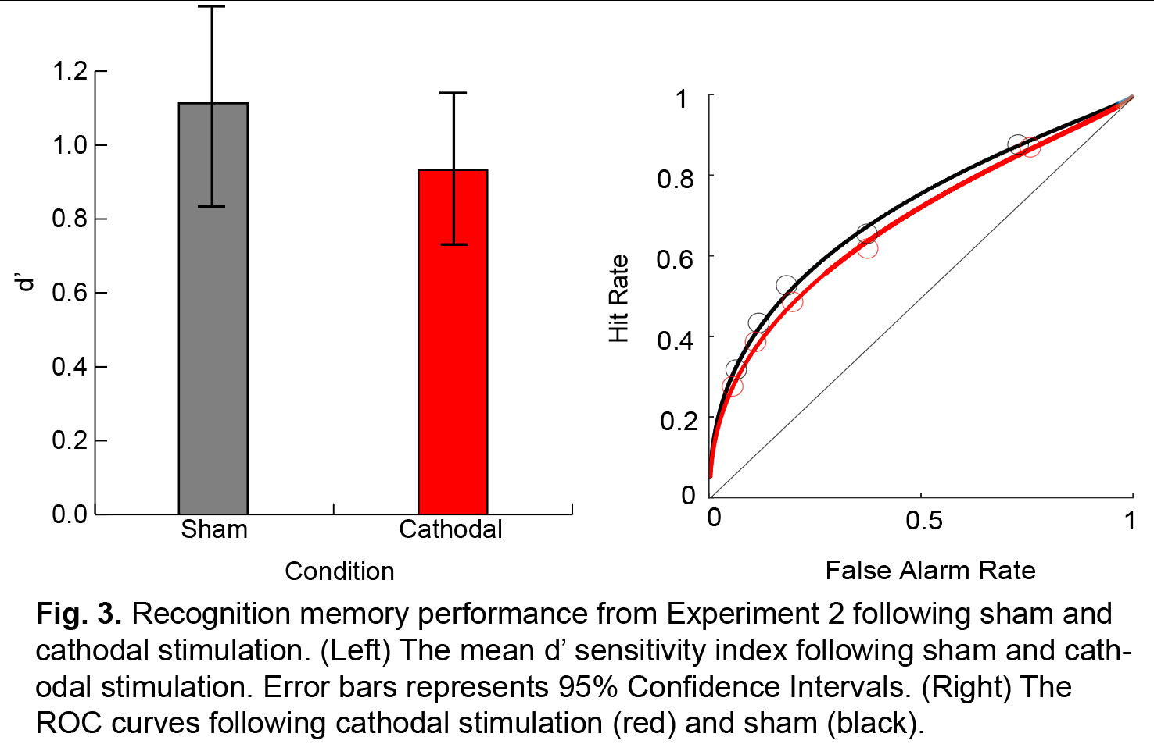had a weaker effect than anodal stimulation. This is consistent with previous studies showing weaker cathodal effects of tDCS compared to anodal stimulation at the same location 6. This has important practical implications as it shows that it is easier to improve human memory with temporal pole tDCS than impair it.

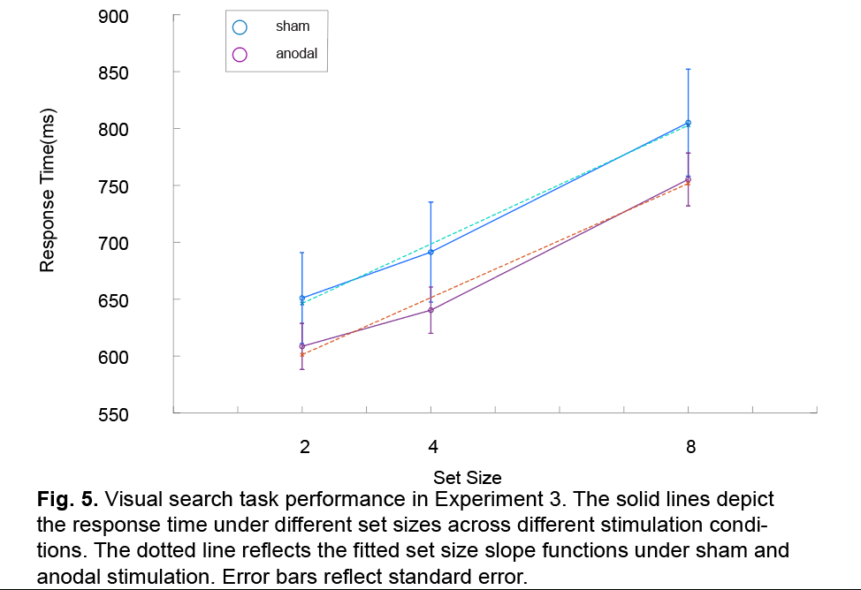In Experiment 3, we tested the synaptic-plasticity hypothesis of tDCS by stimulating the temporal pole, as in Experiments 1 & 2, but using an attention-demanding visual search task (see **Figure 5** for the task and results). Visual search tasks tax selective attention mechanisms, but do not explicitly require memory encoding due to the target remaining the same object across trials. Our results show that even though this same stimulation improved or interference with memory, depending on the polarity of the current, we found no change in the efficiency with which people could search the visual arrays. The accuracy of participants under sham stimulation (mean= 98.94%, SE=0.16%) is almost the same as the accuracy under anodal stimulation condition (mean= 98.84%, SE=0.24%), and the accuracy in both sessions are close to 100% as expected in RT visual search paradigm. Therefore, no speed-accuracy tradeoff had been observed across stimulation conditions.

In Experiment 4, we wanted to test an alternative explanation for the results of Experiment 1. Specifically, it is possible that memory was improved in Experiment 1 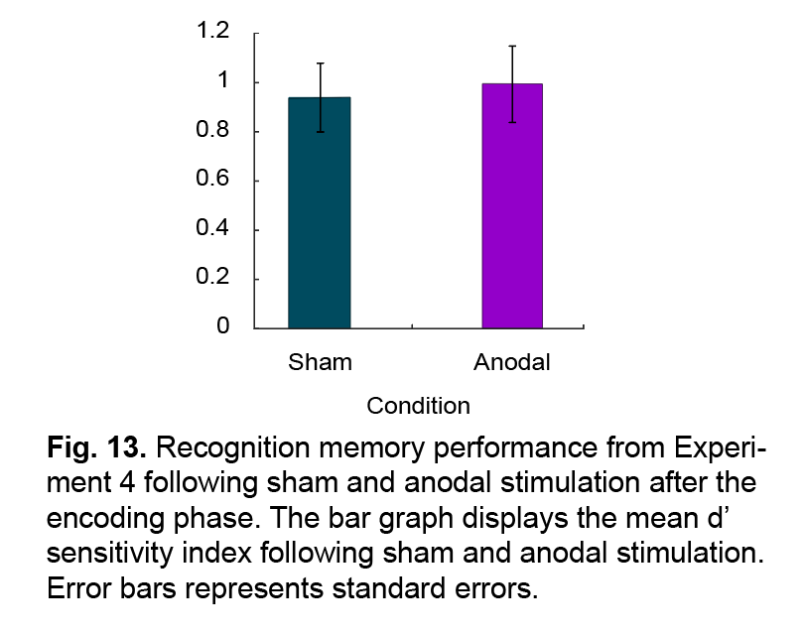because anodal stimulation changed retrieval, and not encoding, despite stimulation being delivered closer in time to encoding. To address this possibility, we ran Experiment 4 in which tDCS was applied prior to retrieval, instead of prior to encoding. The d’ sensitivity in the anodal stimulation was not significantly different compared to the sham stimulation baseline (*F*(31)= 0.560, *p*=0.460, see **Fig. 13**). Meanwhile, anodal stimulation in Experiment 4 didn’t show a significant hemispheric preference (i.e., an interaction of stimulation condition x hemisphere, *F*(31)= 0.877, *p*=0.356).

In our final test of the synaptic-plasticity hypothesis we recorded brain activity following tDCS to provide converging evidence for our conclusion that tDCS potentiates long-term memory encoding, but not retrieval, as predicted by the hypothesis. To this end, we had a group of subjects participate in two sessions, one that began with 20 minutes of anodal tDCS delivered to one hemisphere, and the other the sham baseline. We again found that anodal stimulation improved subjects’ visual recognition memory performance relative to when the same subjects received sham stimulation. Similar to our previous study of the effects of the temporal pole using tDCS, we did not find that which hemisphere was stimulated had an effect (i.e., an interaction of stimulation condition x hemisphere, *F*(23)= 0.209, *p*=0.652), so we collapsed across which hemisphere was stimulated. Thus, the paired t-test with the factor of stimulation condition (sham versus anodal stimulation) showed that our anodal stimulation delivered to the temporal pole improved the recognition memory performance (*t*(23)= -2.988, *p*=0.007).

To investigate the neural signature changes that result in the behavioral improvement, we first performed time-domain analysis on the encoding phase EEG data. The amplitude and scalp distribution of the frontal positivity following anodal stimulation and sham are shown, respectively, in **Fig. 7** and **Fig. 8**. Recall that prior research has shown that when a stimulus elicits a more positive frontal potential that stimulus is remembered better than one that elicits a less positive potential 7,8. Our findings replicate that basic effect, in that our subjects’ frontal positivities were larger amplitude for high confidence hits, smaller for low confidence hits, and smaller still for misses. However, we found that 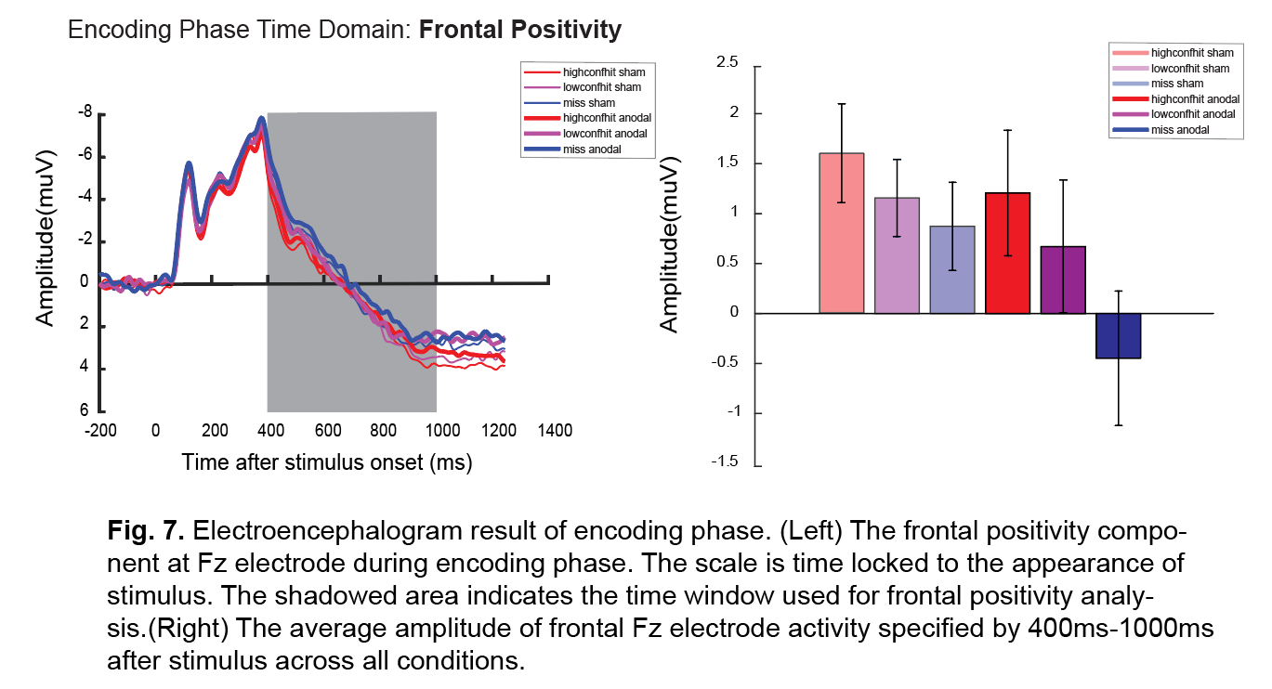stimulation had a negligible influence on the amplitude of these potentials, indeed the waveforms were slightly more positive in the sham session than anodal, as confirmed with our analyses that we discuss next.

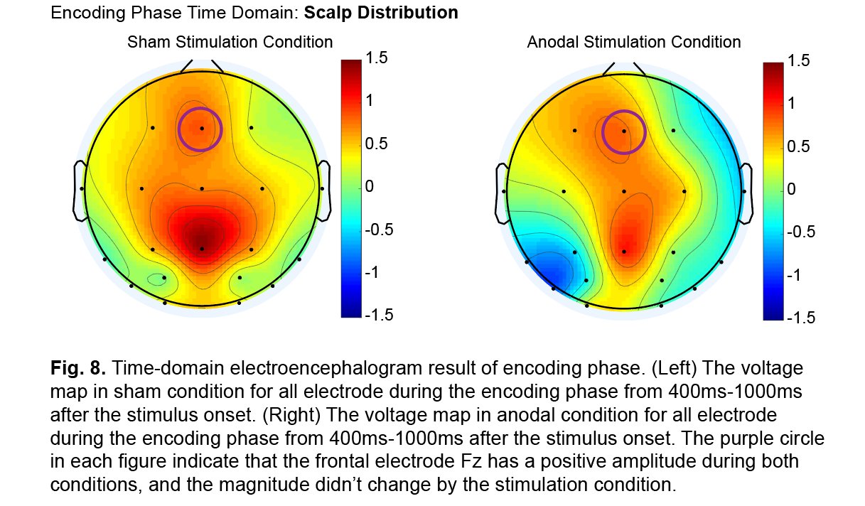We calculated the mean voltage at electrode Fz from 400ms-1000ms following the to-be-remembered stimulus onset. Next, we performed a repeated ANOVA with the factors of subsequent response type (high confidence hit, low confidence hit or miss) and stimulation condition (sham or anodal stimulation). This yielded a significant effect of response type (*F(2,24)*=5.496, *p*=0.007) due to more positive potentials for high confidence hits than low confidence hits or misses, see **Fig. 7**. However, we did not observe a significant effect of stimulation (*F(1,24)*=1.028, *p*=0.321), or an interaction of response type X stimulation (*F*(*2,24*)=0.958, p=0.391).

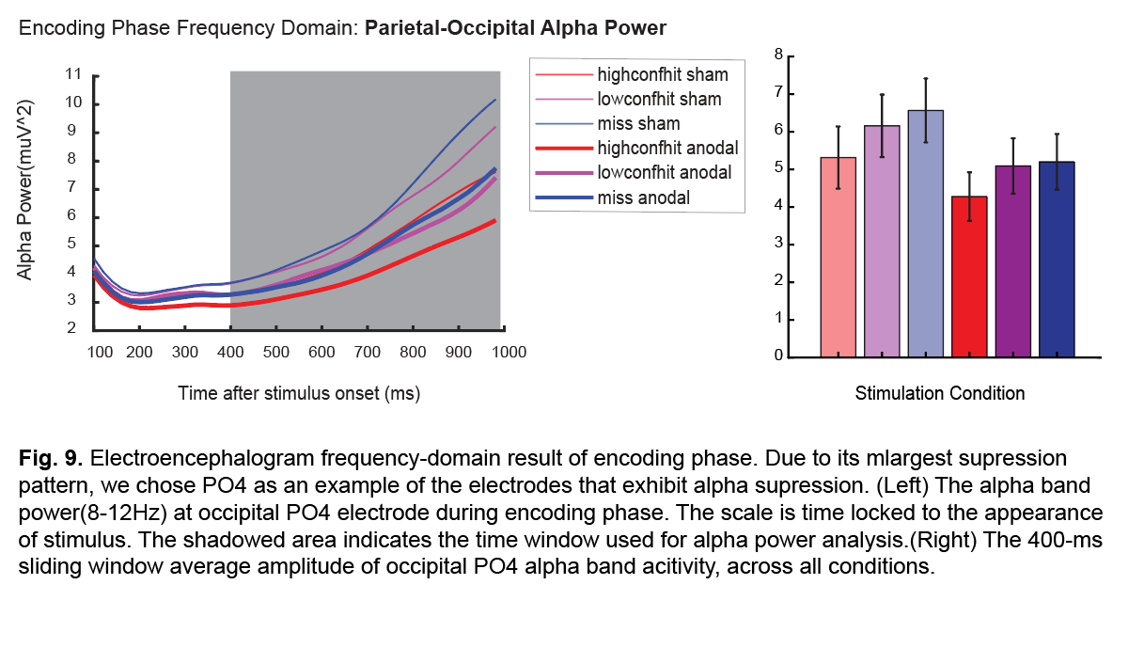In addition to the time-domain analysis, we also performed frequency-domain analysis on the raw EEG data. We next measured alpha band activity to determine whether stimulation changed these memory-related oscillations in the brain. The alpha-band activity measured during encoding is shown in **Fig. 9** and **Fig. 10**. Recall that previous work showed that alpha power was reduced more following the onset of a stimulus that subjects would later report remembering9. We first observed that that we replicated this pattern in our data. However, most critically for the present study, we found that stimulation had a strong effect on alpha in that is decreased alpha power across all to-be-remembered stimulation presentations following anodal stimulation. We quantified this alpha activity by calculating alpha power within a 400-ms sliding window, with 380ms of overlap between windows, from 400ms-1000ms following stimulus onset. These power values were entered into an ANOVA with the factors of subsequent response type (high confidence hit, low confidence hit, versus miss) and stimulation condition (anodal versus sham). This yielded a significant main effect of response type (*F(2,24)*=6.374, *p*=0.007), and a significant main effect of stimulation condition (*F(1,24)*=6.383, *p*=0.019). However, the interaction of these terms was not significant (*F(2,24)=*0.305, *p*=0.740).

To further investigate how alpha activities changed by anodal stimulation during the encoding phase, we also visualized the scalp distribution and time-frequency plot difference between anodal and sham stimulation (see **Fig. 10**). By using paired t-test on every single electrode before and after stimulation, we discovered that other than PO4, the C3, C4, P3, P4, Fz, Cz electrodes also exhibit alpha band power suppression. Moreover, the time-frequency plot on PO4 revealed that the suppression of band power mainly manifested within the alpha-band (8-12 Hz) range. These evidences together confirmed the potential role of parietal-occipital alpha suppression on recognition 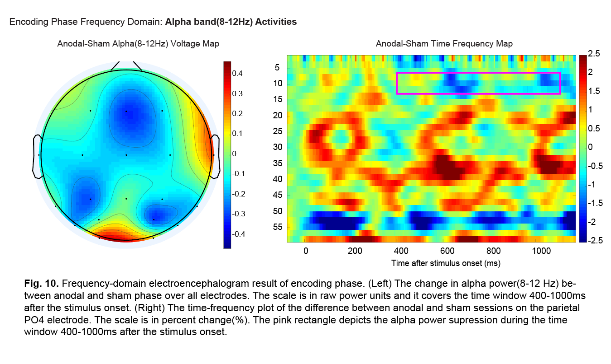memory encoding.

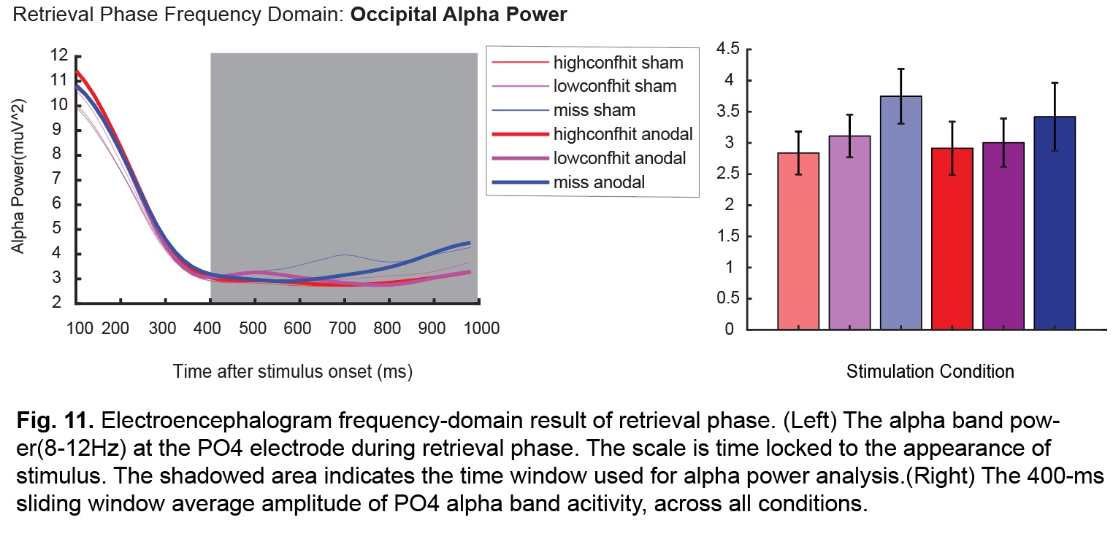One alternative possibility is that the behavioral improvement may result from a higher retrieval efficiency. To investigate whether this hypothesis is true, we also performed the time and frequency-domain analyses on the retrieval phase EEG data. The value of frontal positivity was calculated by the average activity level at Fz electrode site 400ms-1200ms following the stimulus onset. In the frequency-domain, the alpha activity is quantified by the 400-ms sliding window with 380ms overlapping window, and the points were calculated over 400ms-1000ms following stimulus onset. To examine the effect of anodal tDCS on ERP activities, we performed a repeated ANOVA on how response condition (high confidence hit, low confidence hit or miss) and stimulation condition (sham or anodal stimulation) could affect the frontal positivity and occipital alpha-band activities. In the time-domain frontal positivity analysis, we successfully replicated the prior work in that the higher confidence hit condition exhibited higher frontal positivity than the items later forgotton (*F(2,24)*=6.070, *p*=0.008, see **Fig. 11**). However, the Fz site frontal positivity didn’t change with anodal stimulation (*F(2,24)*=0.091, *p*=0.766, see **Fig. 11**). In the frequency-domain occipital alpha-band power analysis, we successfully replicated the prior work in that the higher confidence hit condition exhibited more alpha-band suppression than the items later forgotton (*F(2,24)*=3.642, *p*=0.043, see **Fig. 12**). However, the PO4 site alpha-band power in retrieval phase didn’t change with anodal stimulation (*F(1,24)*=0.507, *p*=0.484, see **Fig. 12**).

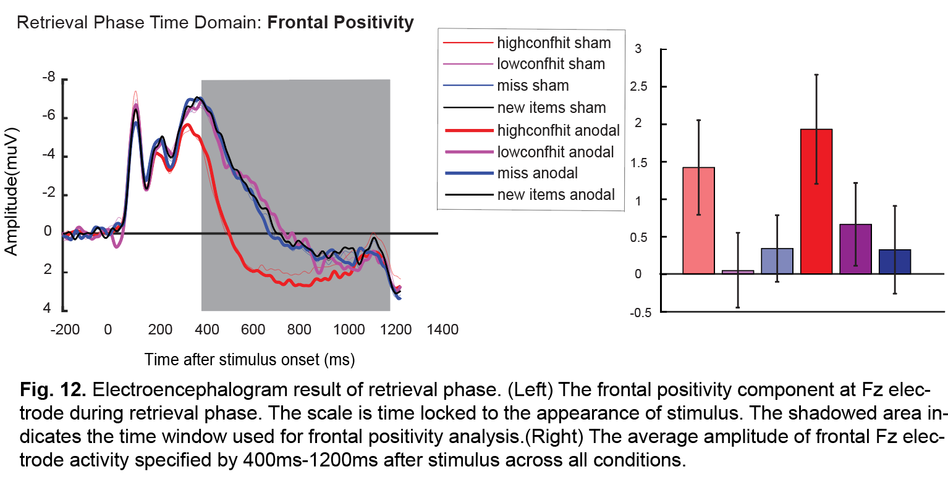 During the encoding phase, we saw that the anodal stimulation promoted the parietal-occipital alpha suppression and left the time-domain frontal positivity intact. However, the anodal stimulation didn’t change either of the neural signatures during the retrieval phase. Given that these retrieval neural signatures still seemed to code for better memory states, one possibility was that the anodal stimulation only selectively affect the encoding state of the participants. Though previous research suggested that tDCS could last for more than 24 hours10, a potential alternative hypothesis is that the stimulation before encoding phase didn’t last long enough till the retrieval state. To further test this hypothesis, we shifted the anodal stimulation to after the encoding phase of the experiment and saw if people could still benefit from the stimulation right before retrieval phase.

**Discussion**

Here we showed that 20 minutes of anodal tDCS delivered to the temporal pole of the healthy human brain could improve the encoding of visual long-term memory, and cathodal stimulation could impair such encoding process. Additionally, these changes in visual long-term memory are not due to a different arousal state induced by the stimulation, as most participants didn’t improve in visual search task performance. The effect of stimulation also, interestingly, did not result in a higher retrieval efficiency in participants. Collectively, our study revealed that the transcranial direct current stimulation selectively altered the encoding quality of healthy human participants.

In tracking the electrophysiological signatures of memory using EEG, we discovered that the anodal stimulation selectively inhibited the parietal-occipital alpha-band power, without interfering the frontal positivity component during the encoding phase. Furthermore, the neural signatures during the retrieval phase remained the same as sham stimulation, mirroring our behavioral findings. This suggested that short-term anodal transcranial electrical stimulation could excite neural tissue activities specifically coded for memory encoding processes. Since the transcranial electric stimulation was shown to influence multiple electric signatures within the brain tissue11-13, our observation of the memory boost under anodal stimulation may result from a downstream long-term potentiation effect of the induced current. Previous research in long-term potentiation suggested that the changes in synaptic plasticity across neuronal populations form human memories14. Particularly, the encoding of long-term memory may selectively reflect activities of calcium-gated ion channels15. Similar to the formation of new memories, these cation-gated channel activities were also modified by transcranial direct current stimulation16. Therefore, our tonic stimulation paradigm may affect the neural plasticity in altering these cation-gated channels, and then selectively promoted the formation of memory.

A recent study of patients with epilepsy found that stimulation of the lateral-temporal cortex could improve declarative memory in patients only if the brain of the patients was is the right state when stimulation was delivered 17. Another study with aging adults suggested that stimulation delivered at specific frequencies determines the effects of stimulation on human memory 18. Given these findings, it seemed unlikely that simple, tonic tDCS could systematically improve memory without targeting the temporal pole in its up state. Our findings suggest that the role played by the cortex at the temporal pole may be simpler than the state dependent and frequency coupled oscillations on which recent work has focused. That is, the content of memories is likely to be stored in the neuronal connections of the temporal pole itself given that neurons in this area code for high-level object properties 19. It is likely that stimulation potentiates neurons at the temporal pole and allows the brain to separate patterns of activity more easily between previously seen items and new items. Finally, the present findings suggest that cortex in the temporal pole is a promising target to improve processing in patients with memory disorders given the simplicity of the equipment and timing needed to apply this type of noninvasive stimulation.

**Methods**

*Participants.* Unique groups of 32 Vanderbilt University undergraduate students participated in Experiment 1-4. Our estimate of the necessary power was based on previous tDCS experiments targeting other brain regions with anodal stimulation in which effect sizes ranged from **η**2=0.9 to 2.3 11,13,20. To achieve 80% power to detect an effect of the same size at the *p* = 0.05 level would require approximately 20 subjects. We obtained a significantly larger sample because cathodal effects are often significantly smaller than anodal effects 21. In exchange for their participation, subjects received either $15 per hour or partial course credit for an introductory psychology course. All participants self-reported having normal or corrected-to-normal vision, no colorblindness, and no history of neuropsychiatric disorders. Subjects’ data were excluded when they did not return for the second session (4 in Exp. 1, 2 in Exp. 2, 0 in Exp. 3, and 3 in Exp. 4). In Experiment 5, two subjects’ data were excluded due to excessive artifacts (i.e., more than 25% of trials rejected due to eye movements).

*Stimulation.* Each session of the experiment began with 20 minutes of 2mA tDCS applied over the temporal pole of the brain or a single-blind sham procedure that was identical to the active stimulation session. In Experiment 1, 3, 4 and 5 the stimulation was anodal. In Experiment 2 the stimulation was cathodal. The tDCS was administered using a battery driven, constant current stimulator (Mind Alive Inc., Alberta, Canada) and pair of conductive rubber electrodes (active: 19.25 cm2 reference: 52 cm2). The electrodes were placed in saline-soaked sponges and held in place by a headband. The active electrode was either placed at T3 or T4 of the International 10-20 system 22. The anodal electrode on the head was paired with a cathodal electrode centered over the ipsilateral cheek to avoid confounding effects from other brain regions. We modeled the current flow using COMETS23. Half of the participants were randomly assigned to left side (T3) anodal stimulation location, and the other half were assigned to right side (T4) anodal stimulation location. Each participant received either right or left side anodal stimulation in one of the sessions, and a sham stimulation session in the other session. The side of stimulation and the order for sham and anodal stimulation within a subject were randomized.

Subjects were given a set of questionnaires at the end of each experimental session to see if they could detect whether the stimulator was on during the 20-minute period during which the stimulation electrodes were on, which direction of current flow was applied (we included a description of the meaning of bi-polarity), and to determine whether discomfort was felt, using our previous established methods10. To evaluate the effectiveness of blinding by the sham procedure, we analyzed the data separately for subjects that correctly identified the sham and active stimulation sessions. In Experiment 1, one subject correctly identified the sham and active session. In Experiment 2, no subject correctly identified both the sham and active sessions. In Experiment 3, two subjects correctly identified both the sham and active sessions. In Experiment 4, four subjects correctly identified both the sham and active sessions. In Experiment 5, one subjects correctly identified both the sham and active sessions. The findings do not differ when these subjects are excluded, so the analyses report findings with all of the subjects included.

*Task.* In Experiment 1, 2, 4 and 5, the experiment consisted of a study phase and a recognition-memory test phase (see Fig. 1) following anodal stimulation or sham. The task was a recognition memory test in which pictures of 500 real-world objects were shown for 250ms each during a study phase 7. The stimuli were adapted from a published set of photographs 24. Subjects were instructed to study each item while holding central fixation so that they could recognize them later. After a 500-ms pre-encoding period, in which the screen was blank except for a central fixation dot, each picture was presented for 250ms. Each picture was followed by a 1000-ms encoding period, during which the computer screen remained blank. After the encoding task, the participants were presented with a 3-minute break between the encoding phase and the recognition test.

During the test phase subjects were shown 750 pictures of real-world objects (i.e., the 500 pictures shown during the encoding phase and 250 new pictures new), with the order randomized. During the test phase, each trial started with the onset of a central fixation dot for 500 ms. Participants were instructed to maintain central fixation until each trial was over. Following the 500-ms fixation period, a picture of a real-world object was presented at the center of the screen. The object was presented until the subject made a key press to indicate whether they had seen that object during the study phase, as well as their confidence. The number keys 1, 2, and 3 indicated that the item was old items, and the larger the number, the lower confidence level the subjects had for that response. The buttons 7, 8, and 9 indicated the item was new, and the larger the number, the higher confidence level the participants had for their response.

In Experiment 3, The visual search task is a modified version of the Landolt C task (Woodman, Vogel& Luck, 2001). Instead of searching for the direction of opening for Landolt C, participants were always asked for the direction letter T is pointing to. The target T pointed to one of the canonical up, down, left or right directions. In the easy condition, one distractor stimulus L would appear on the screen with the target. The medium difficulty condition consisted of three L distractors, and the hard condition consisted of seven L distractors. The position of the target and the distractors were all randomized in each participant. In each trial, the fixation cross would first appear on the screen for 500 ms, followed by a stimuli pattern of either easy, medium or hard difficulty condition. The stimuli pattern would last until the participant pressed one of the four direction buttons on keyboard to indicate the direction letter T pointed to in each trial. The long exposure time of the stimuli pattern is to ensure that participant acquire high accuracy in the visual search task so that response time could be our primary variable of interest in the present study. In each session, the participant would first have the sham or active stimulation for twenty minutes, and complete nine-hundred trials of visual search task.

*Design.* The participant would finish both of the sessions at the other day under a different stimulation condition. In the recognition memory experiments (Experiment 1, 2, 4 and 5), the pictures used in the second session were programmed such that no repeating pictures were reused in the second session of the same participant. Both of the sessions were designed to happen at the same time of a day to minimize the interference of physiological conditions. Meanwhile, the time interval between two sessions for a single participant was designed to be at least forty-eight hours to avoid the remaining influence of stimulation on cortical activity. The dependent variable in the experiment was the d prime sensitivity index, and the independent variable was the stimulation condition. The d prime sensitivity index was an interval variable calculated by $Z_{hit}-Z_{falsealarm}$. The stimulation condition was a two-by-two nominal variable using mixed design. The first level was the condition of stimulation, and it was a within-subject variable containing anodal stimulation and sham stimulation. The second level was a between-subject variable coding for the side of stimulation the participant would get. A mixed-model ANOVA was performed on the d’ sensitivity index. The effect on d’ index was tested on the within-subject sham or anodal stimulation variable and the between-subject right or left hemispheric stimulation variable.

In Experiment 3, The dependent variable in the experiment was response time in the visual search task measured in second. The stimulation condition is a within-subject variable in that every participant received both sham and active stimulation in two separate sessions. Each participant would get either right or left side anodal stimulation in one of the sessions, and a sham stimulation session in the other session. The side of stimulation and the order for sham and anodal stimulation within a subject were randomized. In each session, the participant would perform visual search under three different array sizes (2,4, or 8). This within-subject variable determines the difficulty of the visual search task and is a discrete variable.

**References**

1 Bindman, L. J., Lippold, O. C. J. & Redfearn, J. W. T. Long lasting changes in the level of the electrical activity of the cerebral cortex produced by polarizing currents. *Nature* **196**, 584-585 (1962).

2 Bindman, L. J., Lippold, O. C. J. & Redfearn, J. W. T. The action of brief polarizing currents on the cerebral cortex of the rat (1) during current flow and (2) in the production of long-lasting after-effects. *Journal of Physiology* **172**, 369-382 (1964).

3 Gartside, I. B. Mechanisms of sustained increases of firing rate of neurones in the rat cerebral cortex after polarization: Role of protein synthesis. *Nature* **220**, 383-384 (1968).

4 Ezzyat, Y., Kragel, J. E., Burke, J. F., Levy, D. F., Lyalenko, A., Wanda, P., ... & Sperling, M. R. . Direct brain stimulation modulates encoding states and memory performance in humans. *Current Biology* **27**, 1251-1258 (2017).

5 Cichy, R. M., Pantazis, D., & Oliva, A. . Resolving human object recognition in space and time. *Nature Neuroscience* **17**, 455 (2014).

6 Nitsche, M. A. *et al.* Transcranial direct current stimulation: State of the art 2008. *Brain stimulation* **1**, 206-223 (2008).

7 Fukuda, K. & Woodman, G. F. Predicting and improving recognition memory using single-trial electrophysiology. *Psychological Science* **26**, 1026-1037 (2015).

8 Paller, K. A., McCarthy, G. & Wood, C. C. ERPs predictive of subsequent recall and recognition performance. *Biological Psychology* **26**, 269-276 (1988).

9 Hanslmayr, S., Spitzer, B. & Bauml, K. H. Brain oscillations dissociate between semantic and nonsemantic encoding of episodic memories. *Cereb Cortex* **19**, 1631-1640, doi:10.1093/cercor/bhn197 (2009).

10 Reinhart, R. M. G., Cosman, J. D., Fukuda, K. & Woodman, G. F. Using transcranial direct-current stimulation (tDCS) to understand cognitive processing. *Attention, Perception & Psychophysics* **79**, 3-23 (2017).

11 Reinhart, R. M. G., Wenxi, X., McClenahan, L. J. & Woodman, G. F. Electrical stimulation of visual cortex can immediately improve spatial vision. *Current Biology* **26**, 1867-1872 (2016).

12 Reinhart, R. M. G., Zhu, J., Park, S. & Woodman, G. F. Synchronizing theta oscillations with direct-current stimulation strengthens adaptive control in the human brain. *Proceedings of the National Academy of Sciences* **112**, 9448-9453 (2015).

13 Reinhart, R. M. G., Zhu, J., Park, S. & Woodman, G. F. Medial-frontal stimulation enhances learning in schizophrenia by restoring prediction-error signaling. *Journal of Neuroscience* **35**, 12232-12240 (2015).

14 Morris, R. G. Long-term potentiation and memory. *Philosophical transactions of the Royal Society of London. Series B, Biological sciences* **358**, 643-647, doi:10.1098/rstb.2002.1230 (2003).

15 Elizabeth P. Bauer, G. E. S., and Joseph E. LeDoux. NMDA Receptors and L-Type Voltage-Gated Calcium Channels Contribute to Long-Term Potentiation and Different Components of Fear Memory Formation in the Lateral Amygdala. *Journal of Neuroscience* **22**, 5239–5249 (2002).

16 Nitsche, M. A. *et al.* Transcranial direct current stimulation: State of the art 2008. *Brain stimulation* **1**, 206-223, doi:10.1016/j.brs.2008.06.004 (2008).

17 Ezzyat, Y., Wanda, P. A., Levy, D. F., Kadel, A., Aka, A., Pedisich, I., ... & Gross, R. E. . Closed-loop stimulation of temporal cortex rescues functional networks and improves memory. *Nature Communications* **9**, 365 (2018).

18 Reinhart, R. M. G. & Nguyen, J. A. Working memory revived in older adults by synchronizing rhythmic brain circuits. *Nat Neurosci* **22**, 820-827, doi:10.1038/s41593-019-0371-x (2019).

19 Miller, E. K. & Desimone, R. A neural mechanism for working and recognition memory in inferior temporal cortex. *Science* **254**, 1377-1379 (1991).

20 Reinhart, R. M. G. & Woodman, G. F. Causal control of the neural processing of errors governs learning and behavior. *Journal of Neuroscience* **34**, 4214-4227 (2014).

21 Medeiros, L. F. *et al.* Neurobiological effects of transcranial direct current stimulation: a review. *Front Psychiatry* **3**, 110, doi:10.3389/fpsyt.2012.00110 (2012).

22 Jasper, H. H. The ten-twenty electrode system of the International Federation. *Electroencephalography & Clinical Neurophysiology* **10**, 371-375 (1958).

23 Jung, Y.-J., Kim, J.-H. & Im, C.-H. COMETS: A MATLAB toolbox for simulating local electric fields generated by transcranial direct current stimulation (tDCS). *Biomedical Engineering Letters* **3**, 39-46, doi:10.1007/s13534-013-0087-x (2013).

24 Brady, T. F., Konkle, T., Alvarez, G. A. & Oliva, A. Visual long-term memory has a massive storage capacity for object details. *Proceedings of the National Academy of Sciences* **105**, 14325-14329 (2008).