HP Slate 2 Tablet PC
The Right Business Touch
Create, edit and review content with the light-weight HP Slate 2 Tablet PC, with a full-featured Windows®-based experience, improved touch capabilities and wireless functionality.⁴
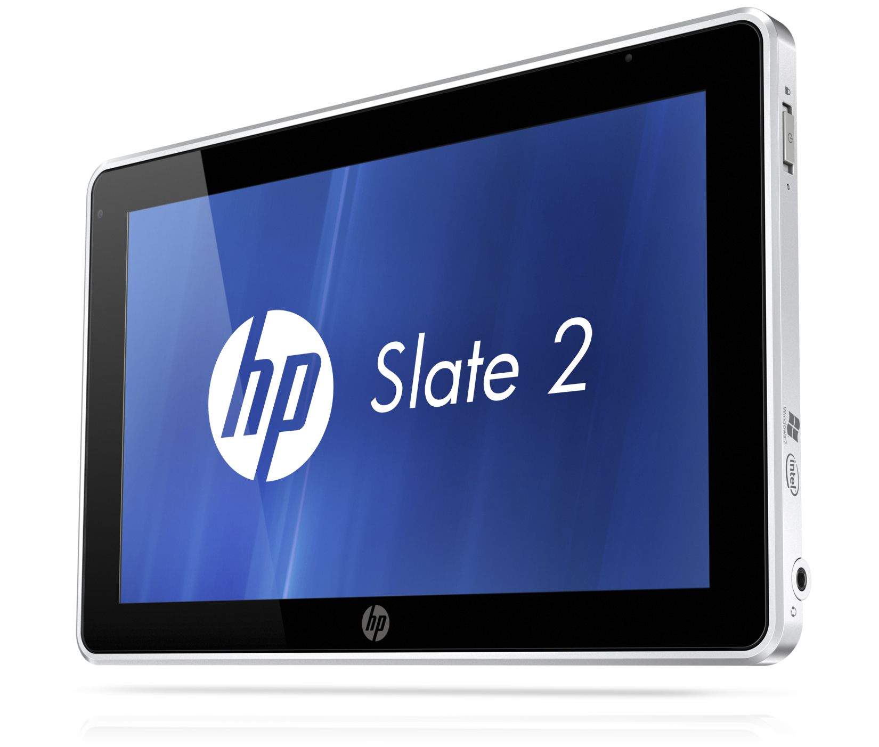

HP recommends Windows® 7.

The HP Slate 2 Tablet PC is ideal for people with jobs that frequently take them away from a traditional desk yet need to remain productive in a familiar Windows® environment or who use custom applications for Windows environments.

Enhanced touch capabilities
The capacitive multi-touch display of the HP Slate 2 lets you navigate on the screen with the touch of your fingers. The Touch Enhancements for Windows 7 improve the navigation and provide easy-to-use touch buttons. Use the optional HP Slate Digital Pen³ and Evernote software to handwrite messages and take notes. The new Swype keyboard enhances the user’s touch experience with a soft keyboard that allows for efficient, fast data entry. Alternatively, users can opt to use the traditional Microsoft onscreen keyboard instead.

Stay productive
With optional integrated HP Mobile Broadband featuring 3G,³ you can conveniently access the internet, corporate networks, email and mission-critical information in more places around the world.⁸ The familiar Windows desktop look and feel helps keep professionals productive while on the go.

Work in the computing environment in which you’re
most comfortable. The Windows 7 Professional 32-bit operating system is one of the pre-installed options on the HP Slate 2 and runs your familiar x86 software, including custom applications.¹⁰ Other Windows operating systems are also available.

Smart design
With a starting weight of only 1.5 lb (0.69 kg), this PC offers an ideal weight and size for mobile professionals. Show videos (such as training or product videos) and stream video from the web on the HP Slate 2.¹ It’s easy to carry from meeting to meeting with the benefits of a full-featured PC.

The flexibility you need
HP has a range of accessories designed to leverage and expand the HP Slate 2. Use the HP Slate Dock³ for a desktop experience and to charge up while you work. The HP Slate Bluetooth Keyboard and Folio is a sleek, stylish executive-class carrying solution that bundles your HP Slate 2, a rechargeable Bluetooth keyboard, Digital Pen, and cards inside a single folio.³

SPECIFICATIONS
Operating system | Genuine Windows® 7 Professional 32¹  Genuine Windows® 7 Home Premium 32¹  Windows® Embedded Standard 7^{1,12}
Processor⁵ | Intel® Atom™ Processor Z670 (1.5 GHz, 512 KB L2 cache, 667 MHz FSB)
Chipset | Intel® System Controller Hub (SCH) SM35
Memory | 2 GB DDR2* on-board memory  *Memory operates at the maximum system supported speed of 800 MHz
Internal Storage⁶ | Up to 64 GB mSATA SSM
Removable Storage | Optional HP External USB 2.0 CD/DVD R/RW Drive³
Display | 8.9-inch diagonal LED-backlit WSVGA wide-viewing angle display  (1024 x 600 or 1024 x 768 for some applications)
Graphics | Intel® Graphics Media Accelerator 600
Audio/Visual | HD Audio – SRS Premium Sound, integrated stereo speakers, integrated microphone, combo stereo headphone/microphone jack; two integrated cameras: VGA Webcam⁷ (inward facing), 3 MP camera (outward facing)
Wireless Support | 802.11a/b/g/n² + Bluetooth®  HP un2430 EV-DO/HSPA Mobile Broadband Module⁸
Expansion Slots | Secure Digital slot: supports SD, SDHC, and SDXC
Ports and Connectors | (1) USB 2.0 port, Power Connector / HP Slate Dock connector, combo stereo headphone/microphone jack; optional HP Slate Dock³: (2) USB 2.0 ports, (1) HDMI connector⁹, (1) combo stereo headphone/microphone jack, and (1) power connector
Input Devices | Optional HP Slate Digital Pen³  Optional HP Wireless Entertainment Keyboard³  Optional HP 2.4 GHz Wireless Optical Mobile Mouse³
Software  (Windows OS only) | HP Slate Camera, EVERNOTE, HP Support Assistant, Swype virtual keyboard, HP Connection Manager, HP GPS and Location (select models only), Adobe Flash Player, HP Shutdown Agent,  PDF Complete
Security | Standard: TPM Embedded Security Chip 1.2, Embedded Security for HP ProtectTools,  Computrace for HP ProtectTools¹¹
Dimensions | 5.9 x 9.21 x 0.61 in / 15 x 23.4 x 1.5 cm
Weight | Starting at 1.5 lb (0.69 kg)
Power | 2-cell (30 WHr) polymer battery, external 30W AC Adapter
Expansion  Solutions | Optional HP Slate Dock³  Optional HP USB 2.0 Docking Station³  Optional HP Essential USB 2.0 Port Replicator³
Warranty | Limited 1 year warranty option available; 1 year limited warranty on primary battery.  For more details visit: http://www.hp.com/go/lookuptool.
HP recommends Windows® 7.
HP Slate 2 Tablet PC

HP recommends Windows® 7.
HP Slate 2 Tablet PC
Genuine Windows® 7 Professional 32¹
Keyboard
button

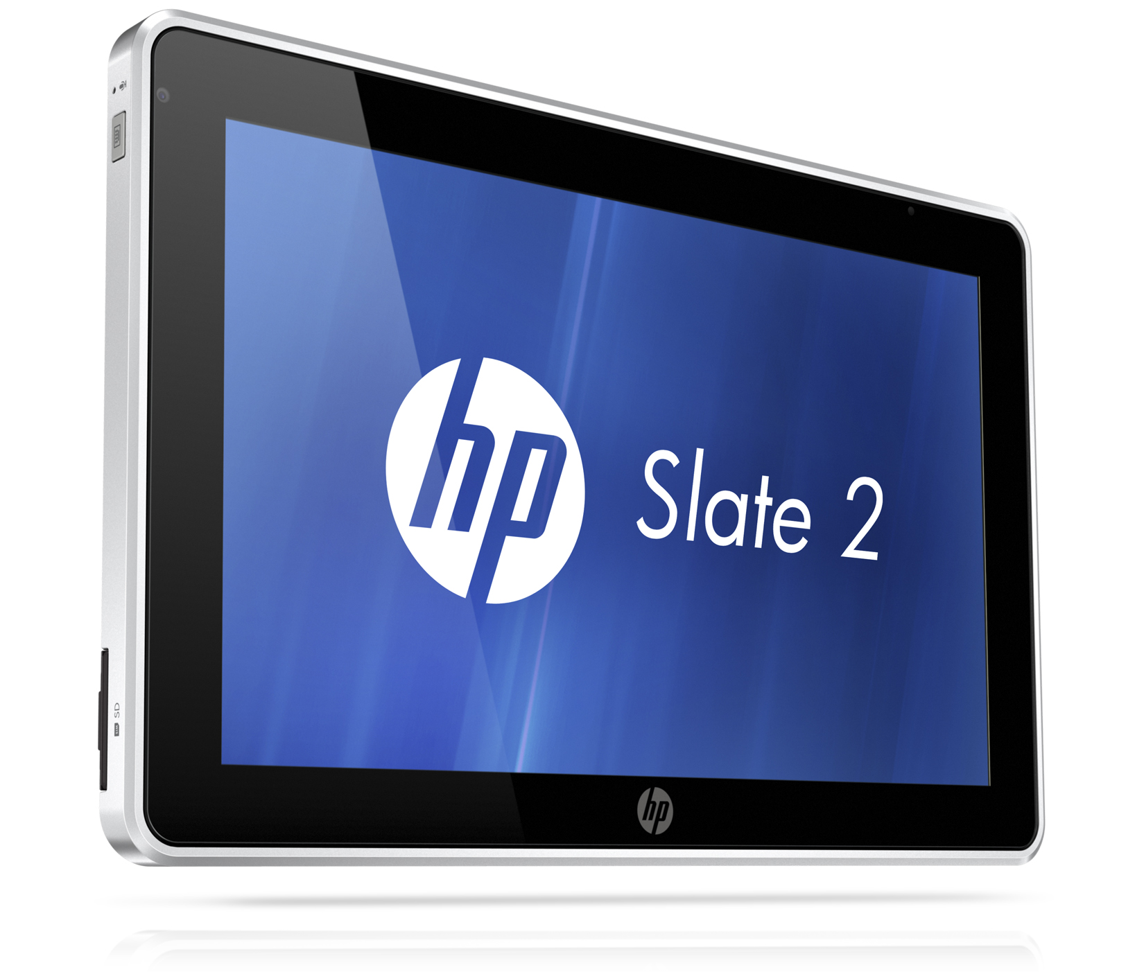
8.9-inch diagonal,
WSVGA capacitive
multi-touch panel with
digitizer

SIM
card slot
SD card slot
Internal microphone
USB 2.0 Port
VGA
Webcam⁷
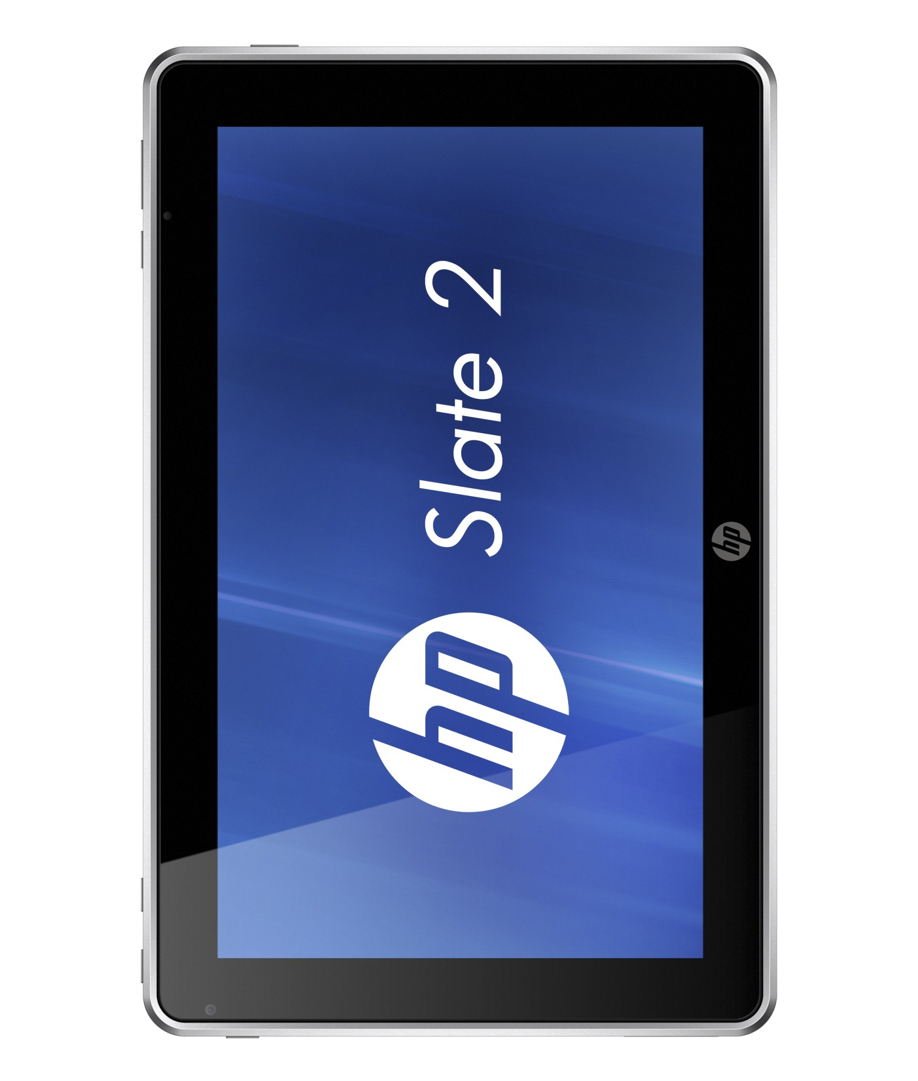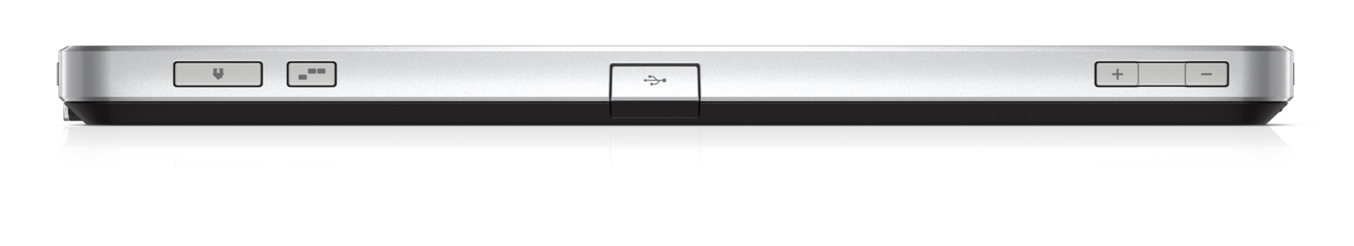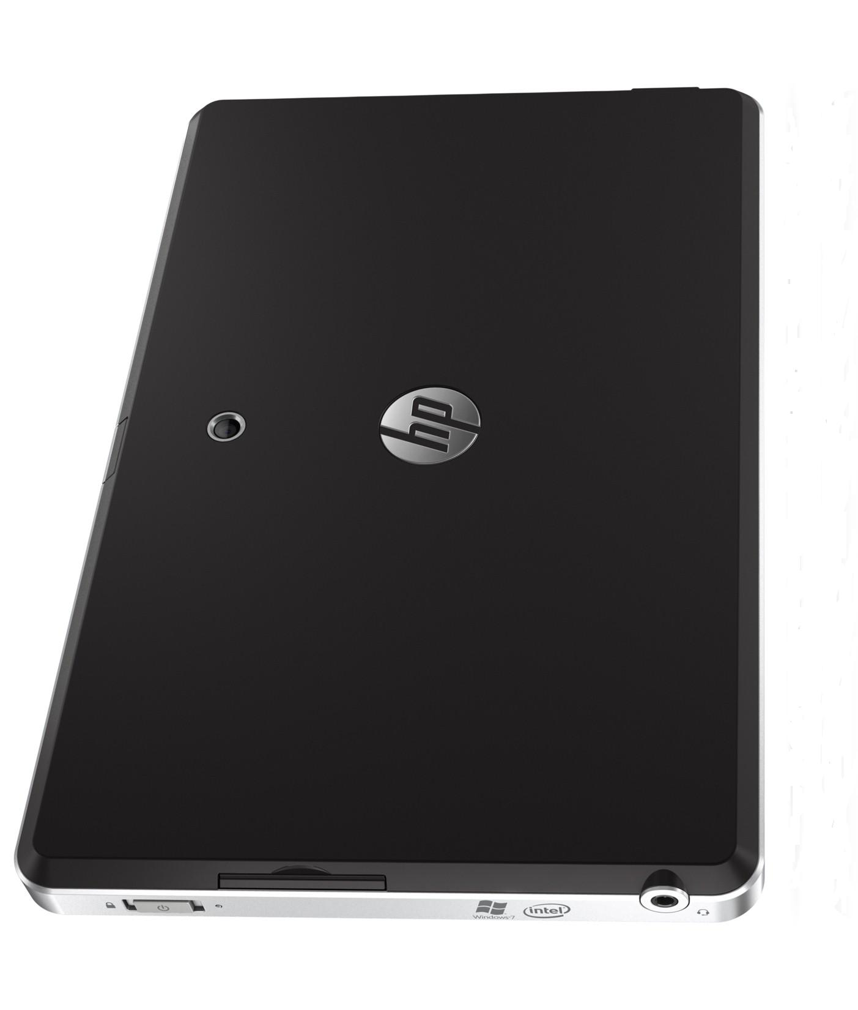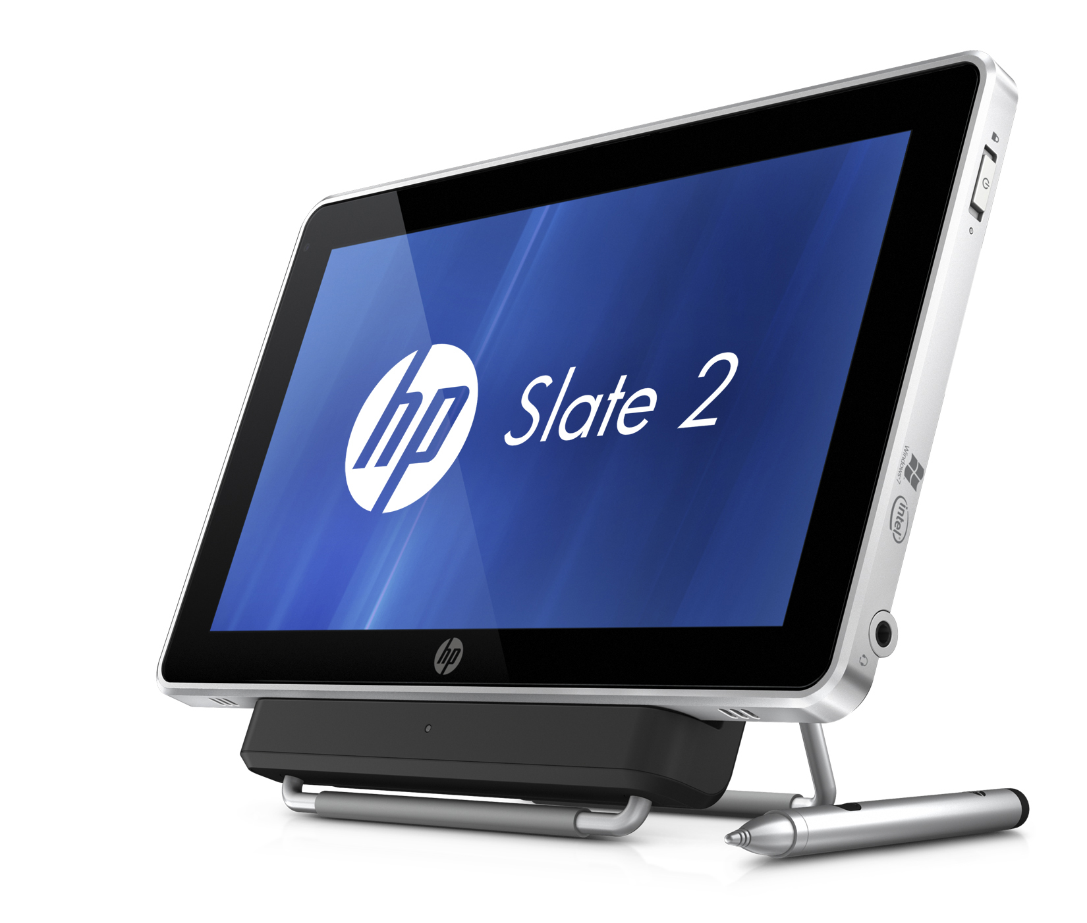
Docking and power connector
- This system may require upgraded and/or separately purchased hardware and/or a DVD drive to install the Windows 7 software and
take full advantage of Windows 7 functionality. See http://www.microsoft.com/windows/windows-7/ for details.
- Wireless access point and Internet service is required and is not included. Availability of public wireless access points limited.
- Sold separately or purchased as an optional feature.
- Requires Microsoft Windows.
- Intel’s numbering is not a measurement of higher performance.
- For hard drives, GB = 1 billion bytes. Actual formatted capacity is less. Up to 15 GB (for Windows 7) of system disk is reserved for the system recovery software.
- Internet access required. Playback may vary due to connection speeds, location, environment, network conditions and other factors. Video-enhanced IM software may be required.
- For optimized WWAN performance, it is highly recommended that the case that came with this device is used when the WWAN is turned on. WWAN use requires a separately purchased wireless service contract. Check with your local vendor for coverage area and availability in your area. Connection and speeds will vary due to location, environment, network conditions, and other factors.
- The HP Slate Dock with HDMI port is required for the monitor connectivity.
- Compatible with 32 bit software and applications only.
- The Computrace Agent is shipped turned off and must be activated by customer when they purchase a subscription. Subscriptions can be purchased for terms ranging from one to five years. Service is limited, check with Absolute Software for service availability outside of North America. For more information, visit www.absolute.com.
- Operating system only available to customers with qualified usage models.

HP recommends Windows® 7.
HP Slate 2 Tablet PC
© 2010 Hewlett-Packard Development Company, L.P. The information contained herein is subject to change without notice. The only warranties for HP products and services are set forth in the express warranty statements accompanying such products and services. Nothing herein should be construed as constituting an additional warranty. HP shall not be liable for technical or editorial errors or omissions contained herein. Bluetooth is a trademark of its proprietor and used by Hewlett-Packard Company under license. Microsoft and Windows are trademarks of the Microsoft group of companies. Intel, Celeron and Core are trademarks or registered trademarks of Intel Corporation or its subsidiaries in the U.S. and other countries. To learn more, visit www.hp.com. November 2011

