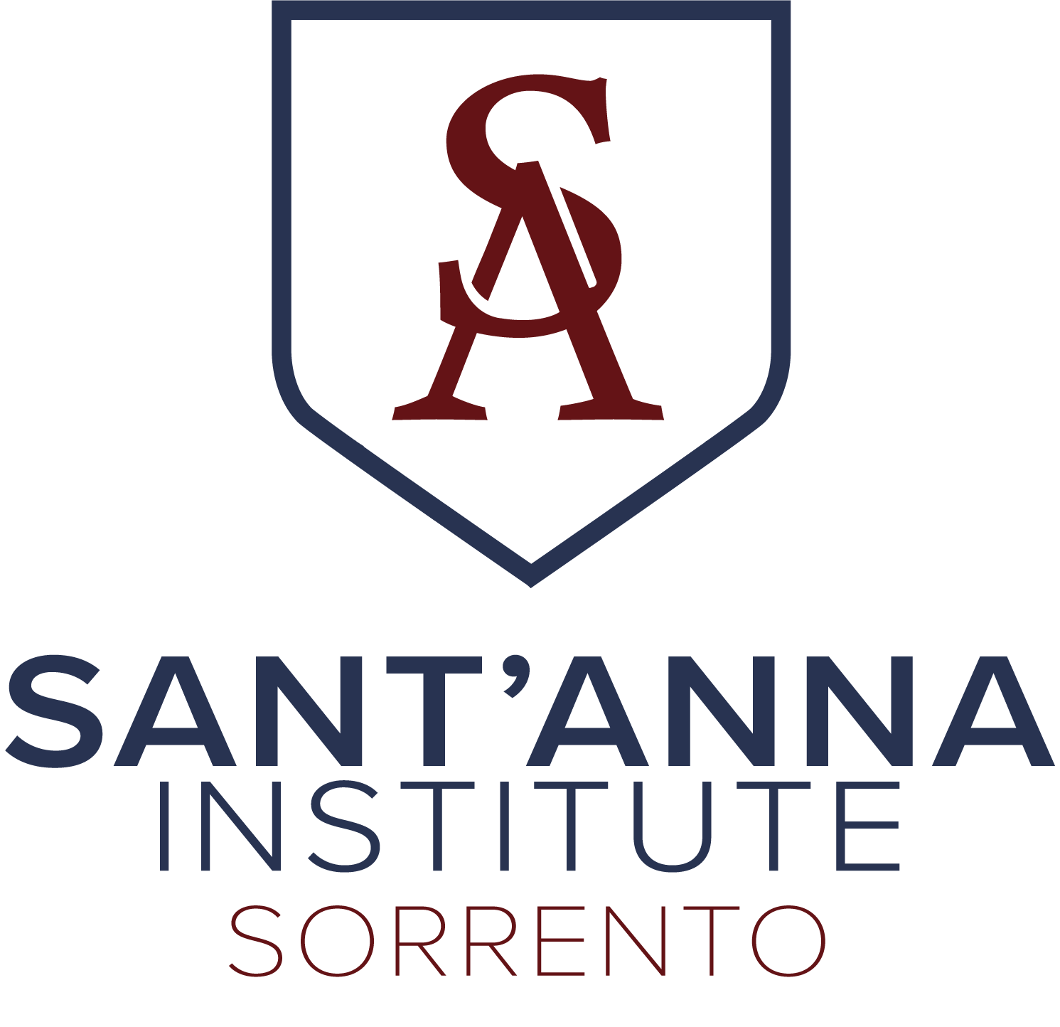

SERVICE LEARNING PROJECT DESCRIPTIONS

Engaging with diversely-abled adults
Students visit one of two local centers that support the daily life of diversely-abled adults from the communities of the Sorrento Peninsula. They participate in the regularly scheduled activities, such as cooking, arts and crafts, ceramics, dancing, etc. Students are encouraged to break through the language and cultural barrier through these hands-on interactions, guided by the organizations’ staff members.

Engaging with the elderly
Students visit an elderly home in a nearby town to do lead an activity interacting with the residents. Given the verbal and physical restrictions of some residents, the activity is visual, such as Pictionary, sketching residents, singing for residents, etc.

Contributing to a student column in local publications
Student volunteers are proposed a topic and guidelines for the article depending on the publication, which may be one of two locally printed magazines for tourists and local residents or an online newspaper. Topics are usually based on local culture or the local territory.

English conversation sessions with low-income locals
Students lead conversations in English with adult members of the community who sign up for the project through the support of the Sorrento town hall. This project allows students to discuss global topics and get to know the local culture and local people.

Marine litter clean-ups
Led by staff from the Marine Protected Area organization, students travel to a marine site on the Sorrento Peninsula to clean marine litter found on land. The litter is divided by material and recycled/disposed as necessary by the MPA organization. Students learn about the global issue of marine litter from professionals while interacting hands on with the environment.

Second-hand clothing sale to fundraise for local museum
In collaboration with a local women’s group that fundraises for the Correale Museum in Sorrento, students, gather and sort donated secondhand clothing, which is then sold in a one-day event in a local square of Sorrento. Students assist the day of the sale to set up, help customers, and take down. All proceeds of the sale go towards the restauration of a painting in the museum.
Engaging with local children
Students visit a local daycare or youth camp in one of the towns on the Sorrento peninsula to interact with children (may be ages 6-months to 14 years-old) during their regularly scheduled activities, such as sports activities, arts and crafts, reading books, singing, dancing, swimming, etc. Students are encouraged to break through the language barrier through these hands-on interactions with the children.

