PAYROLL CALENDARS

Now available from PMP, printed with Your Logo

Make a lasting impression with our 8.5”x11” Calendars
Printed on a coated paper stock, with a semi-gloss finish

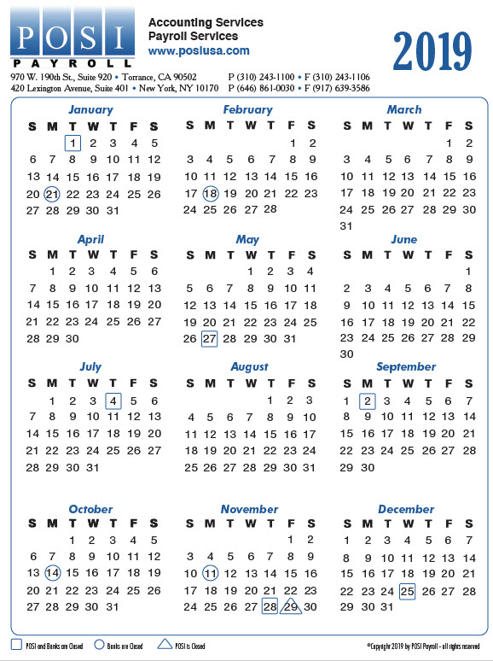
ORDER QTY
QUANTITY | 100 | 150 | 200 | 250 | 500 | 1,000
PRICE/EA | $1.98 | $1.52 | $1.29 | $1.11 | $0.792 | $0.653
Additional Typesetting/ Proof Charge of $65.00, plus UPS shipping.
Pricing includes printing 1‐4 spot colors or full color process.

Ship To: _____________________________
______________________________
______________________________
______________________________ Phone: _____________________
Please email your order and high‐rez logo to jessica.lodi@ourpartners.com
Any questions, please call Jessica or Mike at 800‐545-0792

