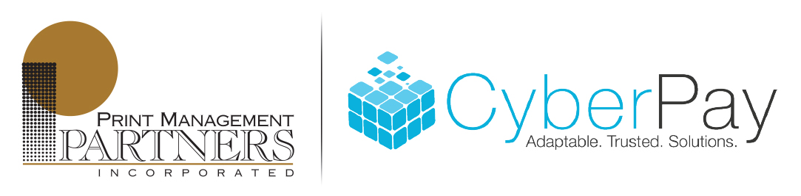
Helping CyberPay Clients to Obtain
Maintain
and Retain clients
no matter where your business takes you
- Print Management Partners specializes in providing high quality payroll consumables and printed pieces that exactly match your software.
- High security, low cost check stock
- Matching security envelopes for hand or machine insertion
- Pressure seal check stock and pressure seal equipment
- All your W2 form needs
- Worksite delivery envelopes formatted to exactly match your software invoice/cover sheet. They help you systemize the worksite delivery process and attractively package your payroll.
- Payroll/PEO specific folder and presentation paper.
- Customizable brochures to help you turn cold calls into warm calls and your prospects into customers.
- W2, 1099 and 1095 print, mail and e-File outsource
Our goal is to be the easiest company with whom you do business!
Our friendly and knowledgeable staff will always serve you with the long-term perspective in mind.

Find out how to receive your W2 envelopes or pressure seal W2 forms FREE
or greatly reduced by participating in our W2 Ad Program!

