NCIL Youth Caucus

Over the last few years, youth have become more active participants in NCIL and the Independent Living Movement more generally. The Youth Caucus, once quiet and dormant, is now a thriving group of youth who meet monthly to discuss youth issues relevant to NCIL’s mission. The Youth Caucus also helps CILs provide the core service of youth transition (transition from K-12 education into college, work, and/or adult life). To get involved or learn more about the NCIL Youth Caucus, join the Youth Caucus Facebook group at https://www.facebook.com/groups/NCILYouthCaucus/.
 | 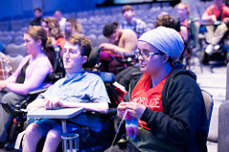
2018-2019 Youth Caucus co-chairs Emily Robinson and Molly Spence pose with Youth Caucus member Issac Zwinger-Nathanson at the 2018 NCIL Conference photo booth. | Youth Caucus members sit and listen during the 2018 Youth Orientation.
 | 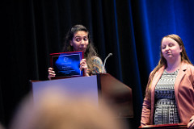
Luke Byram, 2017-2018 Youth Caucus co-chair, smiles for the camera during the 2018 March to the Capitol. | Jessica Jimenez, former Youth Caucus co-chair and current co-chair of the Women’s Caucus and Diversity Committee Chair, stands at a podium and holds up her Diana Viets award for youth with Hindley Williams, 2017-2018 Youth Transitions Fellow looking on.

Youth Membership

NCIL Youth Membership is available to any individual under the age of 26. Youth membership is $110 for a year, and if you cannot pay the membership fee, you can request a dues waiver from Kelly Buckland, NCIL’s Executive Director. As a NCIL member, you’re eligible to vote in NCIL’s elections, you’ll get all the latest updates on Independent Living through NCIL’s Advocacy Monitor, and you’re even eligible to run for the NCIL Governing Board yourself. Though the Youth-At-Large position is the only board position specifically reserved for youth, youth can run for any position on the board. Currently, there are 3 youth serving on the NCIL Governing Board.

NCIL Youth Caucus co-chairs Emily Robinson and Molly Spence pose with Youth Caucus member Issac Zwinger-Nathanson and 2017-2018 Youth Transition Fellow Hindley Williams. They’re holding signs that say “Disabled & Proud”, “Justice for All” and “FIERCE.” | Former NCIL intern and youth member Anna Phearman speaks into a microphone on stage during the NCIL 2018 Rally, wearing a red Mobilize conference t-shirt.
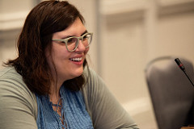 | 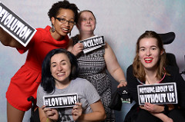
Amity Lachowicz, one of three youth currently serving on the NCIL Governing Board, smiles during the 2018 NCIL Conference. | Former Youth Transition Fellows Keri Gray, Allie Cannington, Hindley Williams, and Kings Floyd pose for a picture in the 2018 photo booth. Their signs say "Revolution", "#LOVEWINS" "#NCIL2018", and "Nothing About Us Without Us".

Youth Scholarship Fund

Attending a conference is expensive. It can be even more expensive for disabled youth, who may not have their own source of income. We created the Youth Scholarship Fund to encourage more youth to attend our annual conference while lowering or removing the financial barrier of registration, travel, and lodging. All disabled individuals under the age of 26 are welcome to apply for a scholarship, though we prioritize those who have been traditionally underrepresented in the Independent Living movement, including people of color, people with intellectual/developmental disabilities, and people who have been formerly incarcerated. The Youth Scholarship Fund grows exponentially every year. In 2018, we had over 30 youth receive scholarships.
NCIL has 3 tiers of scholarship funding, with more or less being allocated on a case by case basis.
- Local Scholarship – up to $110 for individuals living in the DC/MD/VA area
- Regional Scholarship – up to $675 for individuals living in Region 3 – MD, PA, or DE
- National Scholarship – up to $2,200 for individuals living anywhere else in the U.S.
Unfortunately, at this time, we do not have the ability to provide scholarship funds for individuals outside of the U.S. Youth scholarship recipients get a complimentary youth membership to NCIL through the end of the following year.
To learn more about the Youth Scholarship Fund or to be notified when applications for the 2019 Youth Scholarship Fund open, email Cara Liebowitz, NCIL Development Coordinator at cara@ncil.org.

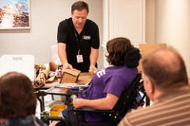
John Flaherty assists youth scholarship recipient Hannah Langlie at the assistive technology demo. | Youth scholarship recipient Issac Zwinger-Nathanson smiles at the Youth Orientation.

