Find Out What the National Center on Intensive Intervention (NCII) Has to Offer
NCII’s mission is to build district and school capacity to support implementation of data-based individualization in reading, mathematics, and behavior for students with severe and persistent learning and behavioral needs. NCII has a growing number of resources to help support the field.
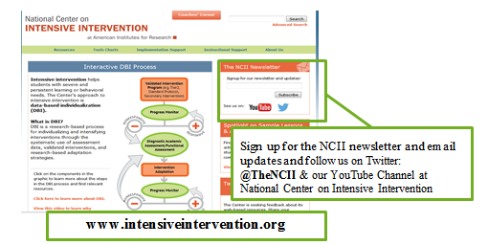
Find Sample Lessons & Activities intended to assist special education teachers, interventionists, and others working with students with intensive needs at http://www.intensiveintervention.org/sample-lessons-activities.
  - Mathematics Sample Lessons & Activities http://www.intensiveintervention.org/resources/sample-lessons-activities/mathematics
  - Behavior Strategies & Sample Resources http://www.intensiveintervention.org/behavior-strategies-and-sample-resources
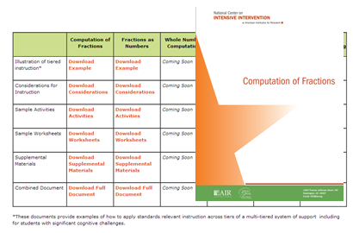
Find training materials to support district or school teams involved in initial planning or implementation of data-based individualization (DBI) as a framework for providing intensive intervention in academics and behavior including PowerPoint slides with speaker notes, activities, handouts, and coaching guides by viewing the Data-Based Individualization (DBI) Training Series, at http://www.intensiveintervention.org/content/dbi-training-series
Register for upcoming webinars and find archived webinars at http://www.intensiveintervention.org/resources/webinars.
Support planning and application of standards aligned instruction across the tiers of a multi-tiered system of support. See examples for reading and math at http://www.intensiveintervention.org/illustration-standards-relevant-instruction-across-levels-tiered-system
Analyze and select evidence-based tools from the NCII Tools Charts and learn about the Technical Review Committees.
  - Academic Progress Monitoring Tools Chart http://www.intensiveintervention.org/chart/progress-monitoring.
  - Academic Intervention Tools Chart http://www.intensiveintervention.org/chart/instructional-intervention-tools.
  - Behavioral Progress Monitoring Tools Chart http://www.intensiveintervention.org/chart/behavioral-progress-monitoring-tools.
  - Behavioral Intervention Tools Chart http://www.intensiveintervention.org/chart/behavioral-intervention-chart.
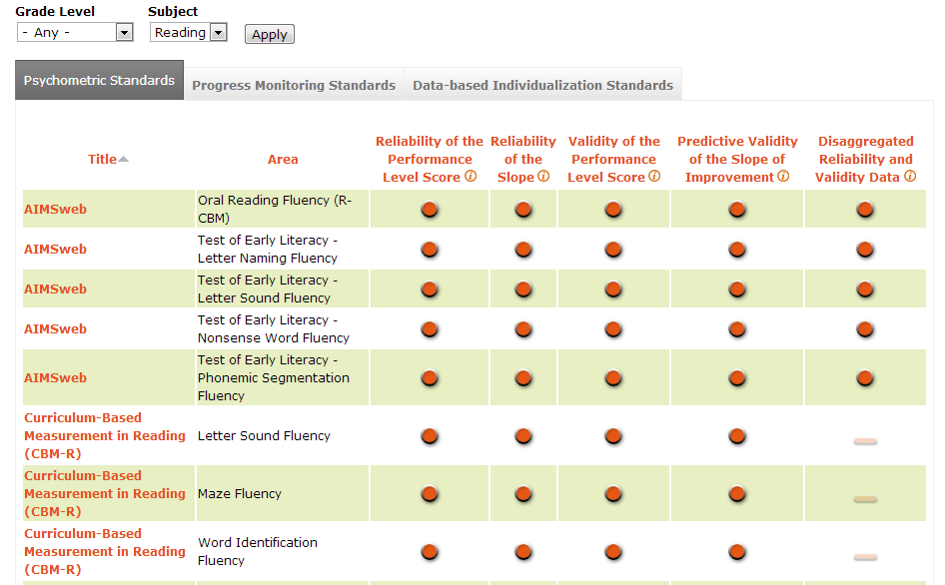
Use the DBI Rubric and Interview to monitor implementation of DBI and the core components of the DBI process. Find the rubric and interview at http://www.intensiveintervention.org/resource/dbi-implementation-rubric-and-interview
Find tools to support individual student data meetings at http://www.intensiveintervention.org/tools-support-intensive-intervention-data-meetings
Find products and resources that will help you learn about data-based individualization and intensive intervention including:
  - Data-Based Individualization: A Framework for Intensive Intervention http://www.intensiveintervention.org/resource/data-based-individualization-framework-intensive-intervention.
  - Synthesis Reports on Intensive Academic and Behavioral Intervention: Annotated Bibliography http://www.intensiveintervention.org/resource/synthesis-reports-intensive-academic-and-behavioral-intervention-annotated-bibliography
  - Implementing Intensive Intervention: Lessons Learned from the Field http://www.intensiveintervention.org/resource/implementing-intensive-intervention-lessons-learned-field.
- View Ask the Expert videos addressing questions related to intensive intervention and supporting students with disabilities at http://www.intensiveintervention.org/resources/ask-the-expert.
- Find definitions of key terms related to intensive intervention within the NCII Glossary of Terms http://www.intensiveintervention.org/ncii-glossary-terms
Contact NCII online at http://www.intensiveintervention.org/about-us/contact, by email NCII@air.org, or on Twitter @TheNCII with questions, comments, or suggestions.

