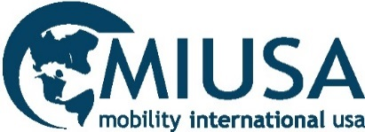

Resources to encourage people with disabilities to
GO ABROAD!

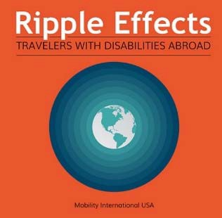 | Ripple Effects Podcast  Travelers with Disabilities Abroad  miusa.org/resource/podcast/rippleeffects | 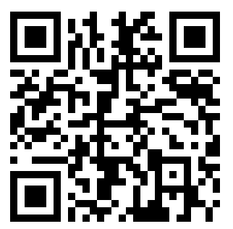
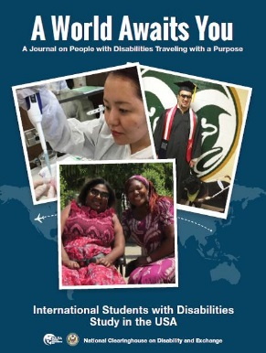  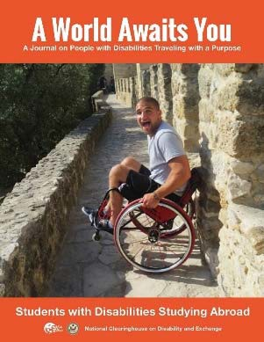 | A World Awaits You Magazine  Featuring American and International Exchange Participants  miusa.org/away | 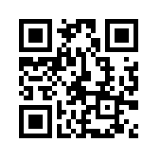
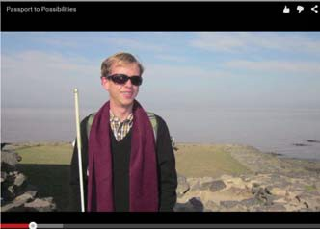 | Passport to Possibilities Videos  Funding Your Travels & Getting Around  miusa.org/news/2015/passportvideo | 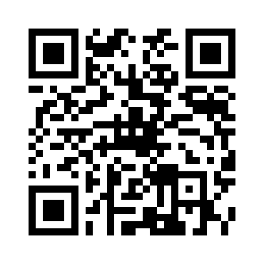
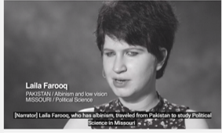 | International Student Videos  Interviews with International  Students with Disabilities  miusa.org/news/2016/access2usavideo | 