Make a Difference: Become a National Liaison

Greetings Fellow Students,

I wish to formally present a fantastic opportunity that will allow you to truly make a difference in the American Optometric Student Association. Becoming a National Liaison for one of the American Optometric Association’s allied organizations is an opportunity like none other. As the national liaison, you will be serving as the channel through which these allied organizations reach the students attending the various colleges of optometry within the United States, Canada, and Puerto Rico.

These positions not only allow you to serve your fellow students in an impactful way, but they also provide you with the opportunity to further educate yourself on one of the various programs offered in the field of optometry. In doing such, you will also be educating your colleagues. Therefore, it is imperative that each National Liaison candidate possesses a passion for the betterment of this profession. An unwavering desire to assist fellow students in becoming the best optometrists that they can be should be at the foundation of any applicant considering a National Liaison position.

Each AOSA Trustee has been equipped with the proper forms to complete your application. On the National Liaison application, you will find the list of available positions. I strongly encourage you to consider this unique opportunity to positively affect the future of optometry.

The application deadline for National Liaisons has been extended to January 31st, 12:00pm CST. Please note that this date differs from the date listed on the online application. Final decisions regarding each position will be made on February 14th. I wish all candidates the very best, and hope that each and every student continues in finding ways to better the profession.

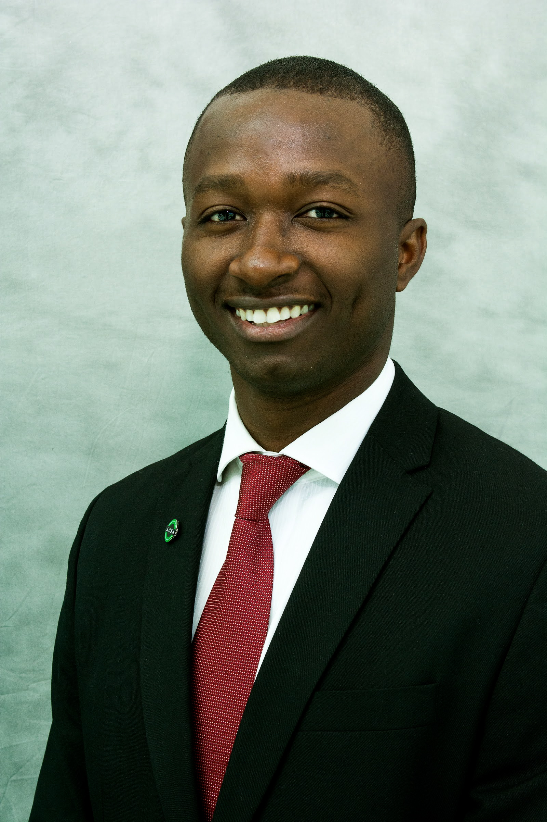

Devin J. Sasser
The University of Missouri-St. Louis College of Optometry
President-Elect, American Optometric Student Association
Website:http://www.theaosa.org/
Email: dsasser@theaosa.org

