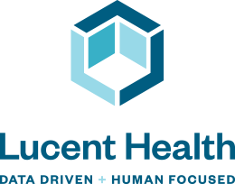

Lucent Health Solutions, Inc.
Products and Services

Organization Overview

Lucent’s history, background, approach, and philosophy
- Lucent Health was founded in 2014

- We have over 40 years of experience with the acquisition of: Capitol Administrators, Cypress Benefit Administrators, and North America Administrators.

- Our acquisition of Narus Health, a highly specialized, patient-centric care management company.

In addition to our deep managed care administrative capabilities, we’ve developed proprietary care management solutions, health plan products, data tools, provider payment systems, and employee engagement software that set us apart from other organizations.

- Our objective is to be the healthcare solutions partner for employers that manages cost, improves health, and creates value.

- We seek to transform the healthcare experience for employers and their employees through the aggressive management of the price per claim, the number of claims, and 24/7 access to the health plan and health plan data.

Lucent’s differentiators in the market
- Vertically integrated and proprietary aggressive care management solutions.

- 24/7 Concierge, Complex Care management solution with proprietary mobile app technology.

- Multiple Service Centers to support clients in the various time zones.

- Access to multiple national carrier networks.

- Robust, National Data Warehouse to support all data requirements and custom analytic requests.

- Proprietary Electronic Provider Payment Portal to support direct contracting initiatives.
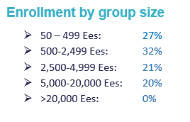
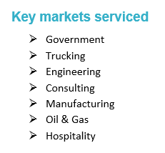

Solution Overview

Lucent’s plan solutions with unique features
- Lucent Health Traditional: fully customizable self-funded health plan allowing flexibility in network, care management, pharmacy benefit management, and wellness.
- Lucent Health Concierge VBP: integrated reference-based pricing solution including inpatient / outpatient pre-certification, pre-pricing navigation, large case management, complex care management, 24/7 concierge support / population management
- Lucent Health Tribal: inhouse MLR solution for tribal members and carrier network or VBP solution services for non-Tribal employees with integrated 24/7 concierge support / population management
- Lucent Health BPO – provide health plan management support for various organizations
- Lucent Health Government – Inhouse Medicare Like Repricing administration
- Lucent Health Rewards – health plan solution with tiered benefits utilizing bio screening scores to reward healthy employees with better benefits
- Utilize wellness partner who provides coordination of bio screening, health risk assessments and wellness coaching to support the rewards-based health plan

Medical Administration
Lucent Health has the technical capability to process medical claims on traditional PPO plans, Reference Based Payment Plans, Level Funded Plans, MEC Plans, Native American Medicare Like Rate plans, Wellness Based Plans, etc. Medical claims are processed in accordance with the terms of both the summary plan document and administrative service agreement along with any Plan Sponsor (Employer) directives. Lucent Health has automated processes that direct the medical claims to re-priced by the appropriate PPO or Reference Based Payment vendor. Our highly experienced and trained claims analyst confirms that the claims are processing as intended i.e. taking appropriate copayments and PPO discounts. The claims analyst also reviews and requests information to determine if there is third party liability or other insurance coverage that should be primary. After processing the claims are forwarded to an outside vendor (zelis) for claims editing and/or Out of Network Pricing. Claims in Excess of $10,000 are checked by QA, in addition, there is a 3% silent audit of claims.

Dental Administration
Lucent Health’s Dental administration is handled this same as Medical. Lucent Health has the technical capability to process dental claims on traditional dental PPO plans or on a traditional Indemnity plan (no network) basis. Dental claims are processed in accordance with the terms of both the summary plan document and administrative service agreement along with any Plan Sponsor (Employer) directives. Lucent Health has automated processes that direct the dental claims to re-priced by the appropriate PPO or process the claim using Usual and Customary pricing guidelines. Our highly experienced and trained claims analyst confirms that the dental claims are processing as intended i.e. taking appropriate copayments, PPO discounts and / or Usual and Customary pricing adjustments. The claims analyst also reviews and requests information to determine if there is third party liability or other insurance coverage that should be primary. After processing the claims are forwarded to an outside vendor (Zelis) for claims editing and/or Out of Network Pricing. Claims in Excess of $10,000 are checked by QA, in addition, there is a 3% silent audit of claims.

Vision Administration
Lucent Health’s Vision administration is handled this same as Medical and Dental. Lucent Health has the technical capability to process vision claims on traditional vision PPO plans or on a traditional Indemnity plan (no network) basis. Vision claims are processed in accordance with the terms of both the summary plan document and administrative service agreement along with any Plan Sponsor (Employer) directives. Lucent Health has automated processes that direct the vision claims to re-priced by the appropriate PPO or process the claim using Usual and Customary pricing guidelines. Our highly experienced and trained claims analyst confirms that the vision claims are processing as intended i.e. taking appropriate copayments, PPO discounts and / or Usual and Customary pricing adjustments. The claims analyst also reviews and requests information to determine if there is third party liability or other insurance coverage that should be primary. After processing the claims are forwarded to an outside vendor (zelis) for claims editing and/or Out of Network Pricing. Claims in Excess of $10,000 are checked by QA, in addition, there is a 3% silent audit of claims.

Flexible Spending Account (FSA) Administration
Lucent Health Flexible Spending Account (FSA) administration is administered in-house and is fully integrated into the Medical Administration process. FSA’s are special accounts where an employee can put money into a tax advantaged FSA to pay for certain out-of-pocket health care costs. You don't pay taxes on this money. This means you'll save an amount equal to the taxes you would have paid on the money you set aside. Lucent Health’s integrated FSA solution provides automatic processing of medical claims which allows Lucent to reimburse the employee. Employee must still submit certain FSA eligible claims to Lucent Health to receive reimbursement.

Healthcare Reimbursement Account (HRA) Administration
Lucent Health Healthcare Reimbursement Account (HRA) administration is administered in-house and is fully integrated into the Medical Administration process. HRA’s are special accounts where an employer can allocate a certain amount of money to each eligible employee who has elected the medical plan to cover medical expenses that go to the employee’s deductible and/or out-of-pocket. HRA’s are typically utilized by employer’s who offer high deductible healthcare plans to their employees to assist with out of pocket costs from medical services. Lucent Health’s integrated HRA solution provides automatic processing of medical claims which allows Lucent to reimburse the employee. Employee must still submit certain HRA eligible claims to Lucent Health to receive reimbursement.

Health Savings Account (HSA) Administration
A health savings account (HSA) is a tax-advantaged medical savings account available to taxpayers in the United States who are enrolled in a high-deductible health plan (HDHP). The funds contributed to an account are not subject to federal income tax at the time of deposit. Unlike a flexible spending account (FSA), HSA funds roll over and accumulate year to year if they are not spent. HSAs are owned by the individual, which differentiates them from company-owned Health Reimbursement Arrangements (HRA) that are an alternate tax-deductible source of funds paired with either high-deductible health plans or standard health plans. Lucent Health assists the client with developing the appropriate HDHP and then partners with specific organizations / banks that specialize in offering HSAs.

COBRA Administration
Lucent Health insources the administration of COBRA administration and administered by Lucent Health staff. Lucent Health’s COBRA administration processes on behalf of our clients the termination of the active coverage for the employee and/or dependents for qualifying events. Lucent Health’s COBRA administration including the Mailing, tracking of the regulated paperwork for election/renewal and/or rate changes for the COBRA continuation of coverage. If continuation of coverage is elected, creation of an accounting ledger for the tracking of timely premium payments so that coverage is updated to extended active coverage or termination. Forwarding of premium payments weekly to the Plan Administrator (Employer) for deposit into the claims fund. For COBRA only administration services, notification to those vendors that premium payment has been received or termination due to lack of premium payment.

Eligibility & Billing
Eligibility / Billing administration is handled according to the Summary Plan Description and Plan Administrator (Employer). We can accept file feeds or EDI enrollments through our LIN portal. Hardcopies via fax or mail are also permissible. The specialist maintains each client according to the Summary Plan Description eligibility / termination language. There is also direct communication with the clients and/or brokers in regard to specific eligibility issues. Monthly review and preparation of an administrative billing that once completed is placed on the LIN server for the client to review and make payment accordingly.

Inhouse Medicare Like Repricing (MLR) repricing for

Native American / Tribal enterprise
Lucent Health provides Medicare Like Repricing during the adjudication of claims. Pricing is obtained real-time using the most recently published Medicare datasets and pricing methodologies. Pricing is obtained across the entire spectrum of Medicare rates such as DRG, ESRD, ASC, Inpatient Psychiatric Facility and Inpatient Rehabilitation Facility. We work with the Fiscal Intermediaries to obtain Medicare pricing on services that are not covered by Medicare but however have a Medicare price.

Other Services
- Consolidated National Data Warehouse – fully customizable data management support
- Electronic Provider Payment System
- Inpatient and Outpatient Pre-certification including discharge planning
- Maternity and Disease Management
- Large and Complex Claim Management
- Population Support and Concierge Complex Care Management

Third Party Services Outsourced
- Carrier provider Networks
- RBP repricing
- PBM
- Subrogation
- Co-Fiduciary Claim Appeal Services

Target clients and current client base
- Target Clients: 100 – 10,000
- 700 Clients representing 275,000 members

Lucent’s programs, services, and capabilities catered towards middle market and large market employers
- Lucent Health Traditional: fully customizable self-funded health plan allowing flexibility in network, care management, pharmacy benefit management, wellness, etc.
- Lucent Health Concierge VBP: integrated reference-based pricing solution including inpatient / outpatient pre-certification, pre-pricing navigation, large case management, complex care management, 24/7 concierge support / population management
- Lucent Health Tribal: inhouse MLR solution for tribal members and carrier network or VBP solution services for non-Tribal employees with integrated 24/7 concierge support / population management
- Lucent Health BPO – provide health plan management support for various organizations
- Lucent Health Government – Inhouse Medicare Like Rates administration

Small Group Products
- Lucent Health Level Funded
- Lucent Health MEC

Narus approach to health care cost management
- Integrated Care Management with proprietary software to identify complex and emerging complex management members supported with 24/7 concierge care management staff
- Narus Health Concierge Complex Care Management – Daily data analysis by team for a more proactive care management solution.

Lucent advantages vs. self-funded arrangements through the BUCAs
Advantages:
- More flexibility in selecting stop-loss carrier partners
- Access to more data including daily feeds, no restrictions, EDI feeds to any data analytic partners, etc.
- Integrate more data driven and member centric care management and wellness solutions
- Implement custom PBM’s including other dovetail PBM savings programs
- Unbundled approach to effective and complete plan management

Client Service
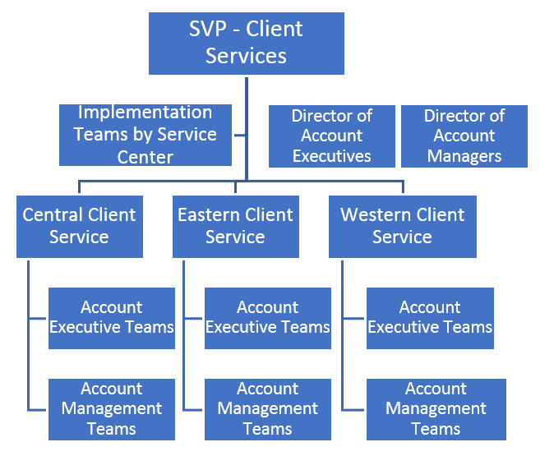
Leadership, Account Management, and support teams.

Tenure and experience:
- Management including Account Executives and Account Managers have 5 – 30 years of healthcare experience

Case load
- Small Market: 25 – 35 clients
- Middle Market: 10 – 15 clients
- Large Market: 5 – 10 clients

Dedicated service teams
- Product and Broker specific PODs dedicated to key national broker partners

Network Details

Direct Contracting
- Facility, Professional, and Ancillary

Provider payment approach
- Discount Fee for Service, % of Medicare, Case Rates and Per Diems

Povider Cost and Selection Criteria
Practitioner
- Confirm current licensure / certification, training and practitioner degree including completion of residency
- Obtain CMS National Provider Identification number
- Drug Enforcement Agency number and/or Controlled Dangerous Substance Certificate
- Five-year work history including license history
- W-9 Form
- Hospital Staff privileges
- Insurance Coverages / AMA profile
Facility
- Current Licensure
- Appropriate Accreditation
- CMS Certificate
- Insurance Coverages

Customized networks on a client-specific basis
- Lucent works with various custom network development organizations
- Lucent Health’s network contract team will work with targeted providers to develop custom networks in key geographic areas

Direct contracting support
- Lucent Health continues to build a dedicated staff for direct contracting to support our narrow network and Reference-based pricing strategies

Reference-based pricing
- (RBP) – Lucent Health is partnered with HST and Zelis to provide RBP services. Note that Lucent has 150 RBP clients representing 85,000 members

Networks Access
- Aetna ASA
- Anthem
- Blue Shield of California
- Cigna PPO, OAP, Local Plus
- First Health
- Cofinity and Cofinity Plus
- HealthSmart PPO
- PHCS / Multiplan
- 60 other rental PPO networks

Unique features
- Proprietary Electronic Provider Payment Portal
- Daily data integration with 24/7 care management interdisciplinary team.

Plan Administration

Claims processing platform
- Utilize two claim platforms: Trizetto and Luminex supported by one data warehouse

Manual claim processing threshold and large claim audits
- Each Examiner has a dollar limit based on experience and prior QA results
- Claims in excess of the specific examiner’s dollar threshold is reviewed by one QA specialists
- All claims over $25,000 are audited by the two QA specialists
- Random 3% audit on all claims and all claim examiners

Fraud, waste and abuse services
- Utilize a combination of service partners including Trizetto, LuminX, Zelis and HST

Member support
- 24/7 Concierge / Population Support – Care Management
- Member Telephonic Services
  - One phone system for the entire enterprise
- Member Portal
- Member App

Member services
- 24/7 Concierge / Population Support – Care Management
- Member Service teams are trained to support specific products, networks and large clients
- Enterprise wide member services training for new staff and additional training for existing staff
- Each service center has a Director of Member Services with Team Leads for various client segments with General Manager oversight
- One phone system for the entire enterprise includes:
  - All member calls are recorded
  - Allows for a one phone number service solution
  - Calls are easily routed as part of our Disaster Recovery plan

Integration/coordination with health plan member services
- Claims, Member Services and Care Management staff operate on a single platform for managing and documenting the member experience

Approach to educating members about the plan
- 24/7 Concierge / Population Support
- Member portal
- Member App
- Customizable Written Communication including enrollment guides and mailed education
- Webinars
- Face to Face (may be limited based on number of locations)

Healthcare Navigation
- Dedicated care management team is available 24/7 to assist with all health care related issues.
- 24/7 Concierge / Population support
- Member Services
- Member Portal
- Member App

Connection to client’s vendors, programs, benefits and resources
- Narus Health will download each company’s summary plan document and care team will route to partner when appropriate.

Demo of app/on-line tools available to members
- Ability to develop a custom on-line web portal for demo site
- Member can down load Lucent Health and Narus Health Apps from the App Store at no charge

Care management
- Narus Health combines the clinical data (claims and pharma) with social determinants of health to create a personalized care plan addressing all needs of member.

Condition Management, Utilization Management, Concurrent Review, Discharge Planning, Transition of Care, etc.
- Precertification and Continued Stay Review: The activities of Lucent Health Care Management’s Utilization Management department include:
- Inpatient and Outpatient Preadmission Review
- Discharge Planning
- Retrospective Review if allowed by group
- Readmission Review
- Discharge planning from day 1 of admission

