Link three assets below to: http://kylewilson.com/resources/

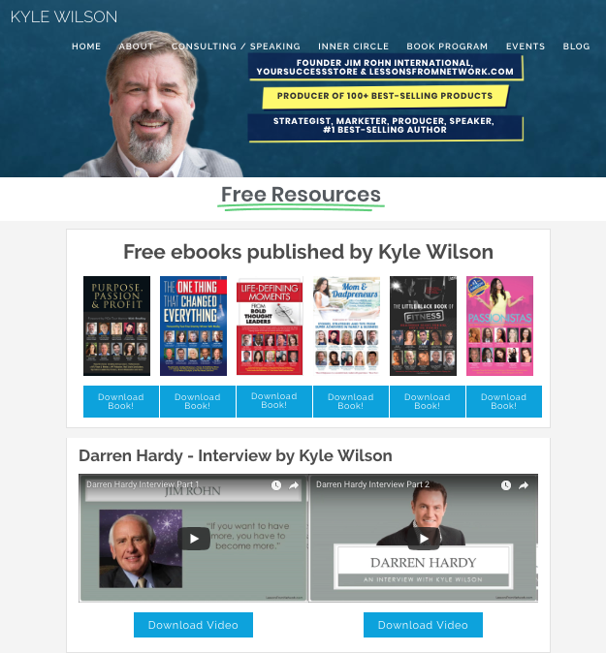

Link one asset below to: http://www.kylewilson52lessons.com/52-lessons

