If you are not keeping score, understand that someone else is!
And that someone else is probably beating you
at the game of money!
This special report will help you discover how money works, how it flows, and how or whether it is working for you!
By using the scorecard technique (it’s SIMPLE!), you’ll be able to easily keep score, and improve the way your hard earned money works for you over time!

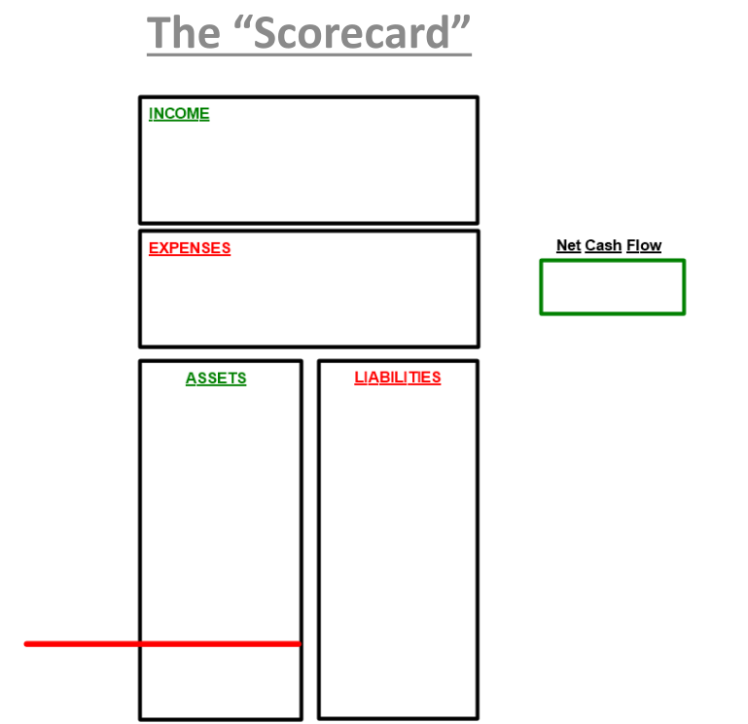

The Problem
“Typical financial advice” coaches you to move your hard earned money AWAY from you.
Incidentally, the sources of that “typical advice” position themselves to have your money flowing toward them. They position you to send your cash toward them.
It’s easy to see when you compare scorecards.

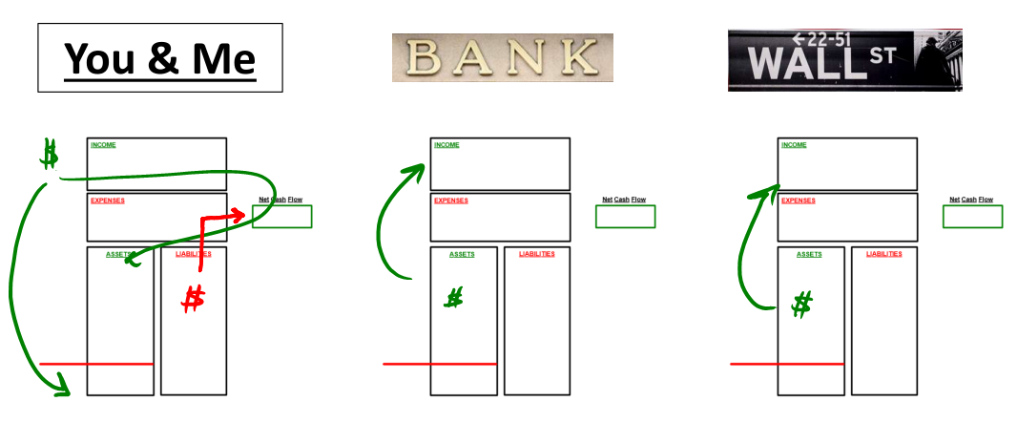

If we just look at the patterns, we can start to see who is positioned to win the game of money!

The Question
So, how do you improve your game?
It’s EASY! Start to track where your cash is flowing, and learn how to position yourself to win.
It all starts with completing a scorecard for yourself.
That part is simple.
I’ll walk you through some common items on the scorecard, where they fit best, and allow you to complete a scorecard for yourself so you can “follow the money.”
First, either print out the scorecard in this report, or simply draw one on a blank piece of paper. (I do this all the time!)
Now, let’s look at the two main sections.

Main Section #1: The Upper Scorecard
In the upper section of the scorecard, you’ll see 3 key areas:
- Income
- Expenses
- Net Cash Flow
It’s usually easiest to complete these sections if you think about it on a monthly basis, although you can do it annually if you prefer.
How do I complete it?
- Simply identify your Net Income in the upper box, (write in a number)
  - Net Income is your after-tax income
  - For example: Net Income is the amount that is deposited into your bank account from an employer
- Identify your expenses in the lower box, (write in a number)
- Then use those two numbers to determine if you have a positive or negative Net Cash Flow at the end of every month (or year) – and write in THAT number in the Net Cash Flow box.
This section typically can reflect round numbers, or averages, but you can run an actual budget if you’d like and make it as detailed as possible, summarizing your budget in these two boxes.
The most important items to consider in the Upper Scorecard:
- Where is your income coming from? (Job, Real Estate, Social Security, etc.)
- What is your Net Cash Flow?

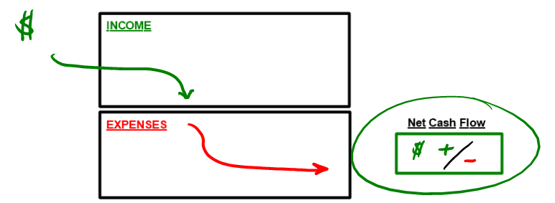

Main Section #2: The Lower Scorecard
In the lower section of the scorecard, you’ll see 2 main columns:
- Assets
- Liabilities
And you’ll notice there is a red line across the bottom of the Asset column.
This red line is important, because any dollars you contribute to or hold in a 401(k) or other similar tax-qualified retirement plan or IRA should be placed BELOW this line.
Why?
Because you are most likely doing so on a pre-tax basis, and Uncle Sam is entitled to a portion of those dollars when you take them as income.
Uncle Sam IS that Red Line!
Also, when your dollars are below the red line, they are typically in an account where you will be penalized if you use them prior to age 59-1/2 (with very few exceptions).
So, those dollars are ON your balance sheet, but they are not all yours, and they are not readily accessible to you. We’re going to put them below the red line!
As you complete this section, here are a few guidelines:
- List out various accounts (or group types of accounts to make it easier) down the left side of the Asset column (on the outside of the box).
  - List cash type assets up top.
  - Add your policy cash value as a cash account!
  - List out real estate and other accounts down the side.
  - If you have a ROTH IRA, notice I place it next to, but just above the red line. This is because it could be tax-free and you may have more access to it than a typical 401(k) or IRA.
- Record approximate values inside the Asset column
- Then on the right hand side, list out various debts owed just outside the right side of the liabilities column, and list each balance inside.
  - You can place any other details out to the right of the liability name
(interest rate, monthly payment, etc.)
- If a liability matches up with an asset (in this example, your primary residence and it’s associated mortgage) link them together.
- If the liability does not have any specific asset associated with it, (credit card, student loan, etc.) simply list it somewhere in the column.
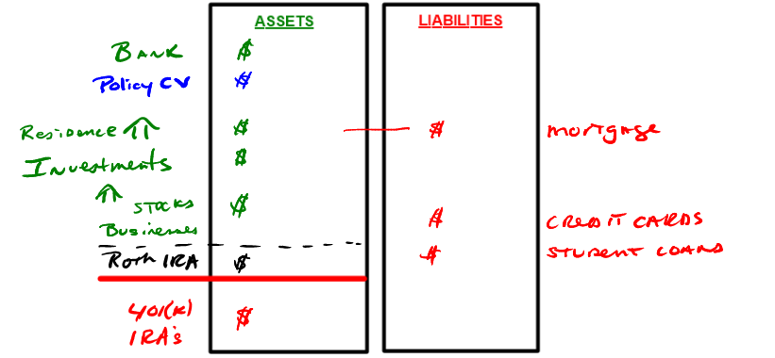

Putting it all Together
Now that you’ve filled in your scorecard, set it down and look it over.
Here are some key questions to ask yourself:
- Where are your dollars flowing?
- Where is your cash flow being directed?
- Is your cash flow MAKING IT DOWN to the lower scorecard?
- If it is making it down to your Asset column, what do you have it doing there?
- Where are you putting your hard earned dollars to work?
- Does your scorecard match up with what you want it to be doing?

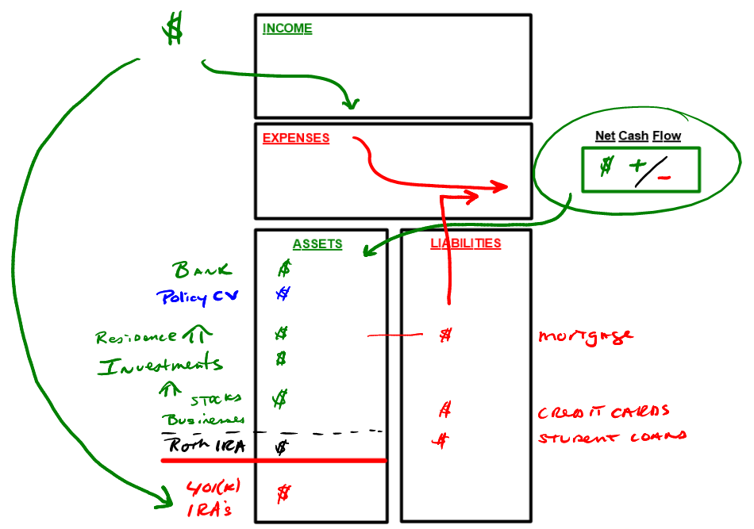

The questions above are all good questions that you can review with a Wealth Strategist.
They can start the conversation about either getting you in position to win, or improving your score to continue to win!

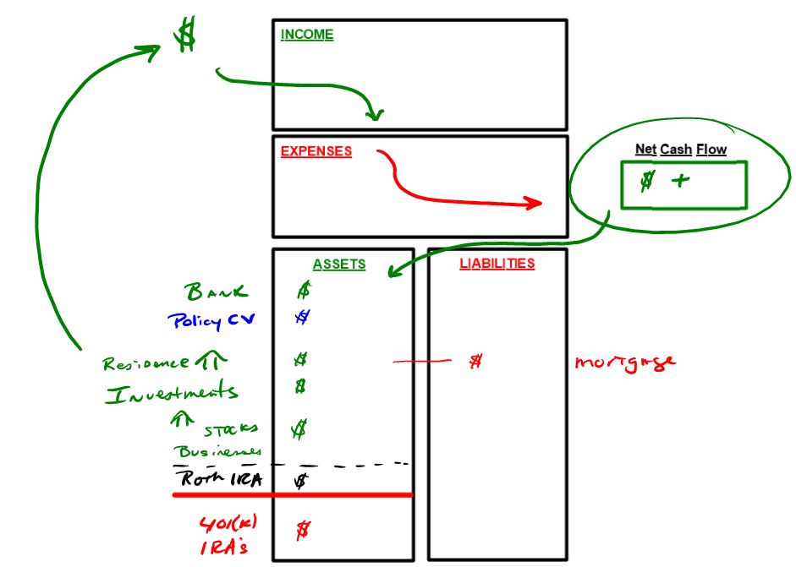

The next few pages can be used to print out and complete a scorecard for yourself.
The page with two scorecards side-by-side can be used to compare where you are today (on the left) to where you’d like to be (on the right). If you decide to use the side-by-side version, complete the left hand side with your current situation. Complete the right-hand side with what you’d LIKE your situation to be. Then go make it happen!!!

Printable scorecard
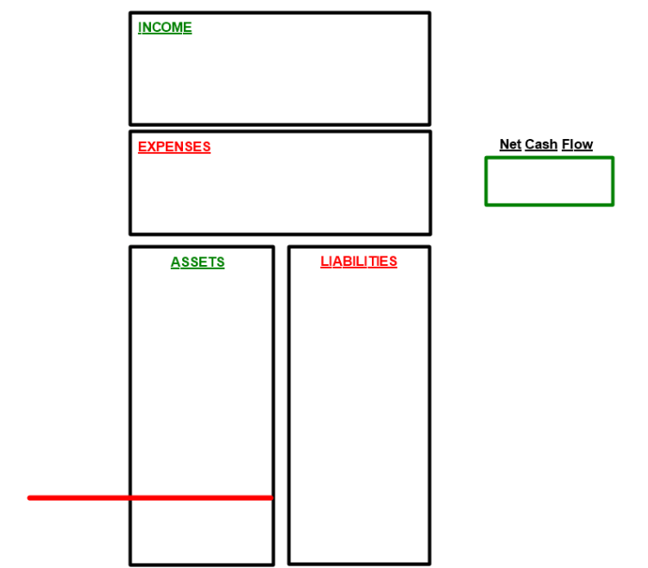

tomorrow
Today
