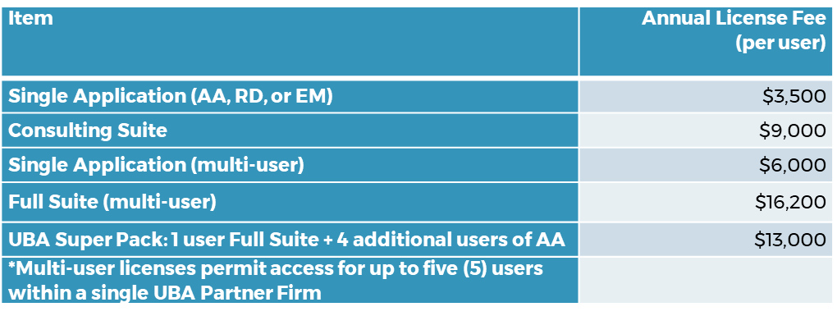
Training and Support Included with the license:
- Access to the Claros Analytics online training library, including training videos and user manuals for all issued licenses
- Initial Training for UBA is done on a weekly basis starting with the 2nd week of the month. One application per week.
- Tier One Support:
  - Available to all users
  - Installation support, functionality of the application, fundamental operations
- Tier Two Support:
  - Actuarial support
  - 12 hours of Tier Two Support to all UBA firms on first come first serve basis is included with the license. Once the 12 hours has been utilized your firm would have to purchase additional support.
- Additional Tier Two Support can be purchased separately by UBA firms in 5-hour blocks at $250/hour ($1,250)
- All active licensed users will receive an invitation to attend Claros-hosted user webinars on a variety of topics throughout the year; open to all active users (usually 6-8 per year)
- One (1) additional training session per year exclusive to UBA members with active licenses; conducted via WebEx, up to three hours in duration.
*Note that this pricing proposal is confidential and exclusive to UBA.
This pricing proposal, and pricing of any license agreement executed based on this proposal, or any subsequent pricing proposal for UBA, may not be communicated to any person or agency outside of UBA.

