Broker Briefcase can drive referrals and win you business by providing thousands of templates and resources to help at any stage—from prospecting to renewals. To help you maximize use, this playbook is designed to mirror the Marketing Hub and familiarize you with the benefits content available in Broker Briefcase.
BENEFITS PRODUCER PLAYBOOK
2020 Broker Briefcase

Find leads and prospect.

Find a Lead
One of the toughest parts of the job is consistently finding new leads and prospects. However, it’s essential for successful agency growth. To find leads, you can search the yellow pages or the internet for local businesses and gather contact information, network with local businesses, ask friends or clients for referrals, and use the DOL Violations Database.
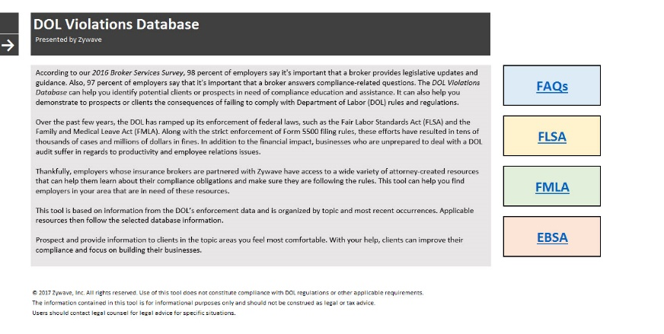
The DOL Violations Database (Document ID: 144116) contains businesses that have had recent Fair Labor Standards Act (FLSA), Family and Medical Leave Act (FMLA) or Employee Benefits Security Administration (EBSA) violations from the Department of Labor (DOL). Use the database to show prospects similar companies who have been fined by the DOL for noncompliance. This database can be an excellent benchmarking strategy to leverage at meetings or during presentations.

Contact a Prospect
You have a list of leads and prospects—now what? Start by researching your prospect. Find out any information your prospect has online. Their website or social media accounts could offer you more information about how to tailor your prospecting approach to their specific needs.
Letters
Before you make a cold call, warm up your prospect by first sending a letter of introduction. This introductory communication could spark your prospect's interest, and it makes your phone call feel like a natural follow-up opportunity. Introduce yourself and your agency to new prospects with ready-made, customizable prospecting letters. Just print out a letter and send it by direct mail, or copy and paste the text from the letter into an email.
Marketing Materials
Show the advantage of a partnership with your agency by including a marketing piece with your letter or email. These pieces are great leave-behinds for your prospects and are customizable to highlight the products and services you offer.
- The Sell the Value series features educational white paper articles on various topics that highlight the services you offer.
- The Total Support Spectrum Flyer – Employee Benefits (Document ID: 130719) highlights the full spectrum of solutions that employee benefits clients experience. Use the Total Support Spectrum Customization Instructions - Employee Benefits (Document ID: 154389) to learn how you can customize the flyer to reflect your agency’s capabilities.

Prospecting Scripts
Using a call script can help you organize your thoughts, anticipate objections and secure a high-quality appointment. The documents below can help you ask targeted questions, uncover pain points and position yourself as the solution. Use this search to find even more call scripts in Broker Briefcase.
- The How Do We Measure Up? Broker Comparison Marketing Checklist – Benefits (Document ID: 36) allows you to highlight the inadequacies of the incumbent broker.
- The Positioning for the BOR: Value Proposition Worksheet - Benefits (Document ID: 66416) provides prospecting questions and corresponding Broker Briefcase documents, covering a wide variety of benefits topics.
Drip Marketing
Even if they weren't ready to make a move when you first contacted them, it's important to stay top of mind and keep prospects warm. One great way to do that is through drip marketing. You can either create a custom campaign or simply pick from a list of pre-created ones to stay top of mind year-round.
Promote your agency.

This section contains resources designed to help agencies establish successful strategies and succeed with Broker Briefcase.
Broker Total Support Spectrum
The Broker Total Support Spectrum Grouping contains resources that show prospects the ability of your organization to provide them with a client-centric experience. The fact sheets and presentations are customizable so that your agency can tailor them to properly reflect its capabilities.
Agency Marketing Posters
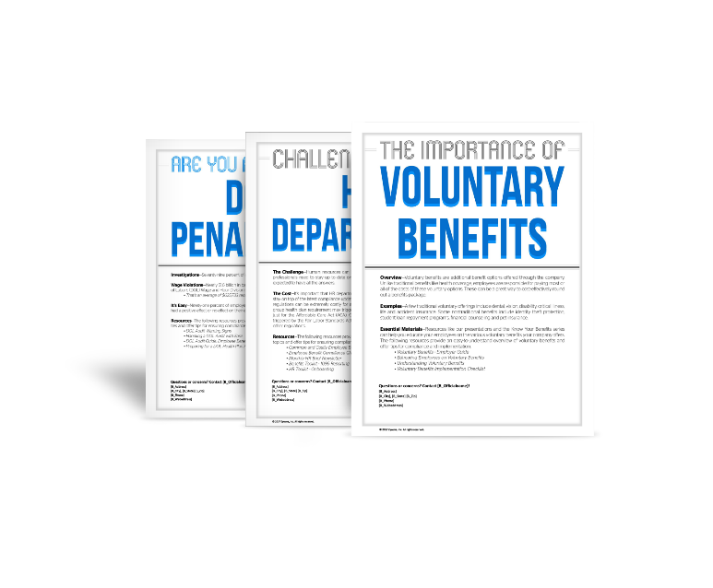
We’ve taken both the guesswork and the legwork out of creating effective and attractive marketing materials. The agency marketing posters, which were introduced to Broker Briefcase last year, cover a variety of employee benefits topics, like voluntary benefits and wage and hour audits, and are customizable. The posters also highlight relevant Broker Briefcase materials that you can provide.
Services and Capabilities Binder
Show prospects and existing clients what you can deliver. These binders contain samples of the types of documents that you offer. The samples within the binder are built using your unique information. There are six designs to choose from.

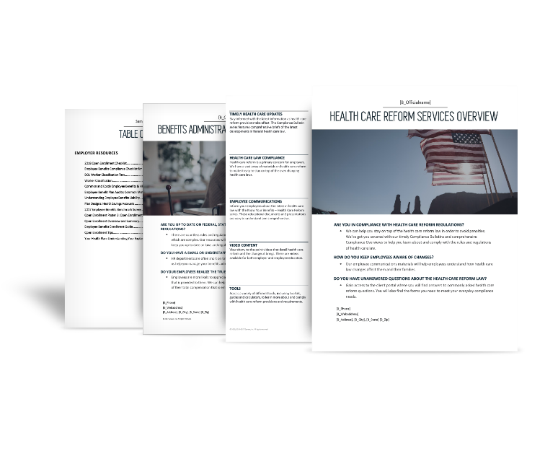
Services Overviews and Services Portfolios
Services overviews and services portfolios show what you can deliver to prospects, and they are great leave-behinds for clients. The two-page services overviews feature examples of the available resources and tools for a specific pain point. The services portfolios feature a sampling of Broker Briefcase content relating to a specific pain point. These overviews and portfolios were redesigned in 2017, so be sure to use these fresh documents to market your agency.
Social Media Marketing
Social media is a great way to increase your agency’s brand recognition, be more accessible to prospects and improve client loyalty. The Succeed with Social Media series provides the tools you need to establish and maintain an effective social media presence.
Promotional Videos
Video marketing is on the rise. It’s a great way to grab consumers’ attention, improve email engagement, increase conversions to leads and boost traffic to your website. Leverage the power of video to increase connections with prospects, and communicate your story in a more engaging way. Check out the suite of services portfolio videos.
Prepare for a meeting.

As you prepare for the meeting, remember to tailor your conversation to the audience you're meeting with. Use any client needs that you identified during your initial contact with the prospect to personalize the meeting. You can use the Prospect Presentation Creator in Broker Briefcase to easily generate impressive prospect meeting packets.
When you meet with your prospect, it’s the first time you can truly show off how your agency differentiates from the competition. With Broker Briefcase, you become your client’s compliance, wellness, HR and benefits expert. This section highlights just a few of the valuable resources, organized by topic, that you can show your clients to show them your true value.
Health Care Reform
Health care reform is a primary concern for employers. Broker Briefcase has a vast array of materials on health care reform to make it easy to stay on top of the ever-changing laws.
Employer Education
Prepare employers with the latest information as health care reform provisions take effect. Browse for “Health Care Reform” under “Legislation & Compliance,” found by browsing all categories.
- The Affordable Care Act Toolkit – Large Employers (Document ID: 78933) and the Affordable Care Act Toolkit – Small Employers (Document ID: 78840) will guide you through the process of assisting your clients with all things health care reform.
- The Affordable Care Act: 2019 Compliance Checklist (Document ID: 159633) offers employers a quick way to ensure they are in compliance.
Employee Communications
Employees need health care reform communications that are easy to understand. Provide that with these articles, payroll stuffers and posters.
- The Health Care Reform: What Does It Mean for You? (Document ID: 39602) document explains to employees how health care reform will directly affect them.
- The Health Care Reform: General Questions & Answers for Employees (Document ID: 41352) article answers commonly asked questions that employees may have regarding the effect that health care reform may have on their benefit plans.
Presentations
Use these comprehensive presentations to educate your clients on the health care reform legislation.
- The Health Care Reform: W-2 Reporting Requirements presentation (Document ID: 69685) explains who the new Form W-2 reporting requirement applies to, when it goes into effect and more.
- The ACA: Section 6055 and 6056 Health Coverage Reporting presentation (Document ID: 126624) provides an overview of the Section 6055 and 6056 health coverage reporting requirements under the Affordable Care Act (ACA).
Affordable Care Act Tools
Educate your clients about the employer-shared responsibility penalties, and help them evaluate and avoid any potential penalties.
- Help clients determine whether they are considered a large employer and therefore subject to penalties under health care reform with the Health Care Reform Large Employer Calculator (Document ID: 83090).
- Use the Health Care Reform Full-time Employee Tracker - Standard Edition (Document ID: 108773) to help your clients determine which employees are considered full time under health care reform and therefore must be offered coverage. Choose between the standard and expanded editions based on your familiarity with the look-back rules and your agency’s needs.
- The Section 6055 and 6056 Reporting Workbooks (Document ID: 115515 and Document ID: 115516) can help save your clients valuable time by recording the information needed for reporting under Internal Revenue Code Section 6055 and 6056 in one place. If your clients have access to MyWave Connect, these workbooks can be uploaded to the portal and used to generate the required IRS forms.
- Use the Benefits Toolkit – 1095 Reporting (Document ID: 133972) to learn all you need to know about Form 1095 reporting and employee communication.
- The Affordable Care Act Pay or Play Calculator (Document ID: 70706) provides an estimate of potential penalties and includes a graphical report illustrating the different scenarios and options.
- The ACA Section 6056 Employer Reporting Guide (Document ID: 135673) provides practical guidance to help applicable large employers that offer insured health coverage (or no coverage at all) satisfy their reporting requirements under Section 6056, which was added to the Internal Revenue Code by the ACA.
Compliance
Staying up to date with all of the rules and regulations governing employee benefits and their changes—many of which are complex and involve mandatory notices and numerous deadlines—can be difficult, costly and, at times, confusing. Use Broker Briefcase to help your clients and prospects remain compliant.
Federal Legislation and Compliance
Access valuable information on the ADA, COBRA, CHIPRA, FMLA, HIPAA (including privacy), Medicare Part D, Mental Health Parity, Section 125, and other federal regulations and employment laws. Browse for your topic of choice under the “Legislation & Compliance” topic.
- DOL Audit Guide: Employee Benefit Plans (Document ID: 96064)
- Section 125: Cafeteria Plan Common Questions (Document ID: 46391)
State-specific Legislation and Compliance
Valuable state-specific information related to topics such as COBRA, FMLA, disability insurance laws, state mandates, cellphone use while driving and domestic partner laws. Browse for a state under “Locations” and find relevant materials.
      - Drug and Alcohol Testing Laws
      - Minimum Length of Meal Period – Laws by State (Document ID: 42674)
Plan Design
Take the guesswork out of employee benefits programs with comprehensive plan design strategies.
Benchmark Surveys & Statistics
Provide your clients and prospects with quality benchmarking data that allows them to analyze how other companies are structuring their plans, as well as the strategies they are using to cut costs, which may help make their own benefit plan decisions easier.
Broker Briefcase features timely annual surveys conducted by Zywave on topics such as broker services, ancillary benefits, vacation and paid time off, health care reform, health plans, wellness benefits and retirement plans.
The Health Plan Design Benchmark Report can be accessed in an online format from the home page of Broker Briefcase. Use this tool to help clients see how their plans match up with comparable employers.
Plan Design Strategies
Uncover the details on benefits plan designs. Browse for “Plan Design” under “Human Resources,” found by browsing all topics.
- Plan Designs: Health Savings Accounts (Document ID: 6030) provides answers to many commonly asked questions related to health savings account (HSAs).
- Voluntary benefits are an increasingly popular way for employers to recruit and retain talented employees at little to no cost. The article Plan Designs: Voluntary Benefits (Document ID: 14564) discusses the advantages of both traditional and nontraditional voluntary benefits.
- More than half of U.S. employers have made the switch to self-insuring their organizations’ health care plans as a way to reduce costs and improve service. The Plan Designs: Self-insurance Guide (Document ID: 14926) document informs employers of the pros and cons of self-funding.
Health Care Consumerism
Consumerism has the potential to benefit both the employer and the employee—as long as the employee is able to obtain, process and understand the basic health information and services needed to make appropriate decisions. Broker Briefcase has the resources to properly educate employers and employees, and empower them to become wiser health care consumers.
Human Resources
HR professionals are asked to do more than ever before. Attracting talent, educating employees, facilitating employee communications and carrying out typical day-to-day operations can be a job in itself. Assist your clients and prospects with HR responsibilities with the vast library of attorney-reviewed articles, toolkits, forms and communications.
Employee Handbook
Enhance the employer-employee relationship and help defend against wrongful termination, discrimination and harassment claims. Regardless of organization size, when properly drafted and legally reviewed, the employee handbook can be the cornerstone of good employment practices. Our sample handbooks and policies can help your clients when they are crafting their own. Browse for “Employment” under “Human Resources,” found by browsing all topics.
- The Employee Handbook with Linked Table of Contents and Appendix (Document ID: 4659) includes a customizable employee handbook and contains links in the table of contents that take you directly to the indicated page.
- The Employee Handbook Checklist (Document ID: 63916) takes your clients through all of the different sample policies you can provide and allows them to check off the ones that they require.
Total Compensation Statements
Employee benefits are only as valuable as employees think they are. Generate additional income for your agency or provide the necessary value-added tools for your client to administer total compensation statements in-house, immediately increasing the value of offered employee benefits and eliminating the extra expense associated with relying on a third-party vendor. Browse for “Benefits Statements” under “Human Resources,” found by browsing all topics.
- The Employee Benefits Statement Instructions for Clients (Document ID: 5286) template explains how to populate the Employee Benefits Statement Data Sheet with employee data.
- The Total Compensation Statement Packet, Completed Sample (Document ID: 32533) is an example of the total compensation statement.

HR Education
Provide HR professionals with the resources they need to succeed. Use the monthly HR Brief newsletter and the HR Insights and HR Q&A series to remain educated on the ever-changing rules, regulations and trends in the HR industry.
HR Toolkits
The HR Toolkits cover a variety of topics like interviewing, onboarding and terminating employees. Each guide provides an in-depth overview of the specified topic and offers best practices for implementation.
Wellness
Provide your clients and prospects with several completely customizable options that deliver everything they need to develop and implement a results-driven wellness program, including posters, guides and surveys to help gauge return on investment.
Workplace Wellness Series
This employer-facing series covers all the considerations for designing a workplace wellness program. Topics include the following:
- Workplace wellness program how-to articles
- Low-cost wellness ideas
- Needs and interests surveys, assessments and evaluations
- Conservation
- Fitness
- General health
- Nutrition and obesity
- Smoking cessation
- Wellness fairs
Wellness Programs
Get your clients’ employees excited about making healthy choices with workplace wellness programs. Broker Briefcase contains everything your clients need to customize, implement and evaluate their own weight-loss, smoking cessation and walking wellness programs. Each program contains all the pieces you need to implement your wellness program:
- The employer guides take your clients step by step through the programs, and the employee guides explain the wellness programs to employees.
- Your clients will use the wellness programs’ posters to promote the programs and get employees excited about participating.
- The program-specific tracking sheets and employee surveys can be used to track participants’ progress, then evaluate the success of the programs after they conclude.

Employee Health and Wellness
Choose from over 500 employee communications designed to promote health and wellness in the workplace and in employees’ everyday lives.
- The monthly Live Well, Work Well employee newsletter keeps employees informed of seasonal wellness tips, from eating healthy to saving money.
- The monthly Live Well, Work Well Video takes two of the monthly articles and transforms them into a targeted two minute (or less) interactive, engaging video.
- The Live Well, Work Well Quarterly Newsletter features an in-depth review of recent health news, highlights three national health observances from the previous quarter, discusses various health and wellness topics, and provides two healthy recipes.
- The Live Well, Work Well flyer series features hundreds of articles on wellness, health, diet and exercise. Send your employees relevant, customizable articles all year long to help them become healthier.
- The Live Well Planner (Document ID: 147629) is designed to make living a healthy lifestyle easier, and it features healthy recipes and various articles on exercise, diet and overall wellness, and provides space for organizing daily and weekly agendas, planning meals or logging workouts.
- The National Health Observances is a monthly list of popular national health and wellness observances that also notes documents related to the observances. A calendar version and an at-a-glance version are available as well.
Employee Communications
Effective communication is key for a productive workforce and for employees to realize the true value of the benefits your clients and prospects provide. Provide customized employee communications to your clients and prospects that are related to benefits education, consumer driven health plans and saving for retirement. Browse for the specific topic under “Employee Benefits.”
Benefits Announcements and Educational Material
- The Benefits Summary (Document ID: 6432) is a detailed summary of benefits suitable for new employee orientation and open enrollment that is specifically customized before distribution to employees. An at-a-glance version is available, too, for a quicker summary.
- The Open Enrollment Employee Video (Document ID: 114775) promotes and explains the open enrollment process for your employees.
Know Your Benefits Series
The Know Your Benefits series is an employee-facing set of educational documents that discusses all aspects of employee benefits from an employee’s point of view. It covers topics such as HSAs, consumerism, voluntary benefits and health care reform.
Basic Benefits Education
The Benefits 101 grouping of documents is designed to educate individuals who have no prior exposure to employee benefits about the basics of coverage.
Broker Resources to Help You Help Clients.

Not sure where to get started? There are a number of reference resources in Broker Briefcase that enable you to become an indispensable partner to your clients by outlining exactly what you can deliver.
Roadmap Your Resources
The roadmaps feature documents listed by topic, so you will always know which document to provide and when.
- HR Roadmap (Document ID: 57401)
- Compliance Roadmap (Document ID: 56685)
- Open Enrollment Roadmap (Document ID: 55147)
- Strategic Benefit Planning Roadmap (Document ID: 69401)
- MyWave Elements Roadmap for Brokers – BE (Document ID: 90277)
- Fee-for-service Roadmap (Document ID: 97276)
- Choice of Coverage Roadmap (Document ID: 86133)
- Workplace Wellness Roadmap (Document ID: 48921)
- Zywave Launch Playbook – EB (Document ID: 90312)
Make the most of your Zywave® products.
Find support for Broker Briefcase with user guides, on-demand videos and a user assistance center, located on the upper right corner of the screen. You can find additional help by navigating to Zywave University.
Also, be sure to check out the Producer Training Program on the Broker Briefcase home page for insight and suggested content to give you an advantage for any stage in the sales process.
And check back often—we are adding new documents all the time. Click on New Documents on the Broker Briefcase home page to view the freshest content.
Looking for marketing information on other Zywave products? You can also find information in Broker Briefcase by browsing for the specific product under “Zywave Products.”
- Decision Master® Warehouse
- HRconnection®
- MyWave Connect®
- MyWave Elements™
- PlanAdvisor®
- ZywaveRx
- PlanDoc Builder
- Intygral

