Annual Conference on Independent Living

Every year, NCIL hosts an Annual Conference on Independent Living in Washington DC, attended by over a thousand people with disabilities and their allies. Our conference is five days long and includes presentations by leaders of the Independent Living movement, a jam-packed exhibit hall, and a march and rally on Capitol Hill. The conference concludes with a celebration dance, where you can show off your sweet moves and get silly at the photo booth!
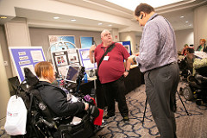 |  | 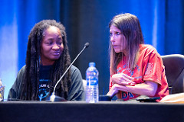
NCIL Conference attendees discuss during the Assistive Technology demonstration. | 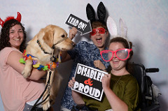 | Dawn Russell presents at a session at the 2018 NCIL Conference with Anita Cameron looking on.
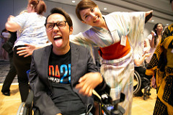 | Three people and a dog pose for a photo in the 2018 photo booth. Two people are wearing bunny ears and prop sunglasses; one is wearing devil horns; and the dog is wearing a lei. | 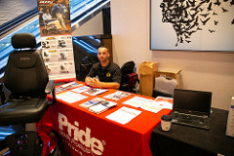
Two people break it down on the dance floor of the closing social. One is sticking his tongue out for the camera and the other is wearing a kimono. |  | A Pride Mobility representative smiles while sitting at the Pride Mobility exhibit booth.

March and Rally on Capitol Hill

The highlight of our Annual Conference is our March and Rally on Capitol Hill. We march over a mile from the Grand Hyatt hotel where our conference is located to the West Front Lawn of the Capitol building, chanting and shouting about the importance of disability rights all the way. Once there, we hold a rally with an impressive lineup of speakers, including members of Congress and leaders in the Independent Living and disability rights movements. Even a rainstorm can’t stop us!

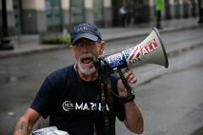 |  | 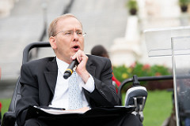
Mark Derry uses his bullhorn to direct the crowd during the 2018 March to the Capitol. The bullhorn has stickers that say "Don't Roll Back Our Rights", "ADA", and "America for ALL". | 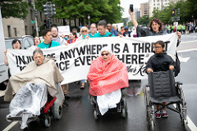 | Rep. Jim Langevin speaks into a microphone during the Rally.
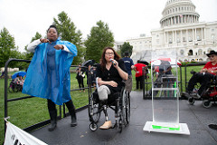 | A group led by Kelly Buckland and Judy Heumann lead the 2018 March to the Capitol in front of the banner “Injustice Anywher is a Threat to Justice Everywhere”  -Martin Luther King. | 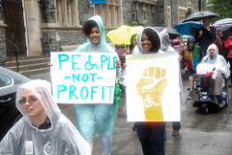
Senator Tammy Duckworth speaks into a microphone on stage during the Rally, with an ASL interpreter beside her and Kelly Buckland looking on. |  | Two people carry signs that say "People Not Profits" (with the universal symbol of accessibility) and ENOUGH (with a raised fist and the universal symbol of accessibility in the 2018 March to the Capitol.

